Quick Wash


By:

Syed Ahmed Ali Shah
22943
Hammad Bin Riaz
28591

Supervised by:
Mr. Shahzad Ahmad Khan

Faculty of Computing
Riphah International University, Islamabad
Spring 2025
A Dissertation Submitted To

Faculty of Computing,
Riphah International University, Islamabad
As a Partial Fulfillment of the Requirement for the Award of the Degree of
Bachelors of Science in Software Engineering

Faculty of Computing
Riphah International University, Islamabad

Date: 5-4-2025
Final Approval

This is to certify that we have read the report submitted by Syed Ahmed Ali Shah (22943), Hammad Bin Riaz for the partial fulfillment of the requirements for the degree of the Bachelors of Science in Software Engineering (BSSE). It is our judgment that this report is of sufficient standard to warrant its acceptance by Riphah International University, Islamabad for the degree of Bachelors of Science in Software Engineering (BSSE).

Committee:

1 | MR. Shahzad Ahmed Khan  (Supervisor)
2 | DR. Musharaf Ahmad  (Head of Department/chairman)

Declaration

We hereby declare that this document “Quick Wash” neither as a whole nor as a part has been copied out from any source. It is further declared that we have done this project with the accompanied report entirely on the basis of our personal efforts, under the proficient guidance of our teachers especially our supervisor MR. Shahzad Ahmed Khan. If any part of the system is proved to be copied out from any source or found to be reproduction of any project from anywhere else, we shall stand by the consequences.

___________________________
Syed Ahmed Ali Khan
22943

___________________________
Hammad Bin Riaz
28591

Dedication
We dedicate this project to Allah Almighty our creator, our strong pillar, our source of inspiration, wisdom, knowledge and understanding. He has been the source of our strength throughout this program. Also, we dedicate our work to our family, friends and teachers. The unrivalled encouragement from our parents and outstanding support from teachers is what led to the success of this project. We also dedicate our work to our supervisor Mr. Shahzad Ahmad Khan and the faculty members.

Acknowledgement

First of all, we are obliged to Allah Almighty the Merciful, the Beneficent and the source of all Knowledge, for granting us the courage and knowledge to complete this Project.
We are grateful to our supervisor Mr. Shahzad Ahmad Khan for his enthusiasm, patience, insightful comments, helpful information, practical advice, and unceasing ideas that always helped us tremendously in our project. Without his support and guidance, this project would not have been possible. Also, a special thanks to the rest of the faculty members for their unconditional support

___________________________
Syed Ahmed Ali Shah
22943

___________________________
Hammad Bin Riaz
28591

___________________________
[Name of Student 3]
[SAP Id]

___________________________
[Name of Student 4]
[SAP Id]

Abstract

Our initiative, Quick Wash, is a mobile-based platform for vehicle maintenance and washing that is intended to cater the needs of Pakistan’s busy vehicle owners. Unlike typical service station models, Quick Wash offers a handy home service feature, where customers can avail vehicle services at their doorstep through a request-based system. This solution ensures that the service station can accept requests on the basis of real- time availability of the employees, optimizing service delivery and downtime. Additionally, the Employee Management System allows station admins to monitor and manage the services across multiple locations, ensuring quality service and timely responses. Quick wash aims to provide the leverage of saving time to their customers while empowering the service stations with a management system, meeting the needs of growing demand of home-based services in the automobile maintenance sector.
Table of Contents
List of Figures xi
List of Tables xiii
Chapter 1: 2
Introduction 2
1.1 Opportunity and Stakeholder 2
1.1.1 Gap in the Market 3
1.1.2 Technology Advancements 3
1.1.3 Changing Customer Needs 3
1.1.4 Demand for Home Vehicle Services 4
1.1.6 Stakeholders 4
1.2 Motivation and Challenges 4
1.2.1 Motivation 4
1.2.1.1 Personal Experience 4
1.2.2 Challenges 5
1.2.2.1 Service Availability 5
1.2.2.2 Customer Safety Concerns 5
1.3 Solution Overview 5
1.3.1 Project Scope 6
1.3.1.1 Home Service & Request System 6
1.3.1.2 Employee Management System Modules 6
1.3.1.3 Admin Module 6
1.3.1.4 Payment Integration Module 6
1.3.1.5 Customer Feed Back & Reviews 7
1.3.1.6 Notification 7
1.4 Report Outline 7
1.4.1 Chapter 1 7
1.4.2 Chapter 2 7
1.4.3 Chapter 3 7
1.4.4 Chapter 4 8
1.4.5 Chapter 5 8
Chapter 2 10
Literature/Market Survey 10
2.1 Report Outline 10
2.2 Literature Review/Market Survey 10
2.2.1 Online Survey 10
2.2.1.1 Reason for Online Survey Technique 12
2.2.1.1.1 Important Question 12
2.2.1.1.2 Key Features 12
2.2.1.1.3 Existing Software 13
2.2.1.1.4 Authentication & Security 13
2.3 Brainstorming 13
2.4 Existing System 14
2.5 Summary 15
Chapter 3 17
Requirement Analysis 17
3.1 Introduction 17
3.2 Problem Scenarios 17
3.3 Functional Requirement 19
3.3.1 Request System for Home Services 19
3.3.2 Employee Management System for Service Stations 20
3.3.3 User Registration 21
3.3.4 Complaint & Feedback System 22
3.3.5 Admin Dashboard 22
3.3.6 Customer 23
3.3.7 Employee 23
3.4 Summary 24
Chapter 4 26
System Design 26
4.1 Introduction 26
4.2 Architecture Diagram 27
4.3 Detailed Design 28
4.3.1 Use Case Diagram 28
4.3.2 Use Case Fully Dressed Format 32
4.3.2.1 Customer 32
4.3.2.2 Service Provider/Manager 44
4.3.2.3 Employee 54
4.3.2.4 Admin 59
4.3.3 Activity Diagram 64
4.3.3.1 Customer 64
4.3.3.2 Service Provider/Manager 71
4.3.3.3 Employee 80
4.3.3.4 Admin 86
4.4 Summary 89
Chapter 5: 91
Implementation 91
5.1 Endeavour 91
5.1.1 Team 91
5.1.2 Work Breakdown Structure 91
5.2 COMPONENTS, LIBRARIES, WEB SERVICES, AND TECHNOLOGIES 97
5.3 IDE, AND TOOLS 97
5.4 Best Practices/ Coding Standard 97
5.5 SUMMARY 99
Chapter 6 101
Testing and Evaluation 101
6.1 Introduction 101
6.2 Test Case Design 101

List of Figures

Figure 2.1: Prefer home service | 10
Figure 2.2: More Useful features | 11
Figure 2.3: Brainstorming | 13
Figure 4.1: Architecture Diagram | 27
Figure 4.2: Customer Use Case | 28
Figure 4.3: Service Provider/ Manager Use Case | 29
Figure 4.4: Employee Use Case | 30
Figure 4: Activity Diagram-Customer | 66
Figure 4.6: Activity Diagram-Registration | 66
Figure 4.7: Activity Diagram-Login | 67
Figure 4.8: Activity Diagram-Manage Profile | 68
Figure 4.9: Activity Diagram-Browse Service | 68
Figure 4.6: Activity Diagram-Select Service | 70
Figure 4.6: Activity Diagram-Adding Location | 71
Figure 4.6: Activity Diagram-Adding Vehicle Information | 72
Figure 4.6: Activity Diagram-Send Request | 73
Figure 4.6: Activity Diagram-Cancel Request | 74
Figure 4.6: Activity Diagram-Make Payment | 75
Figure 4.6: Activity Diagram-Receive Notification | 76
Figure 4.: Activity Diagram-Service Provider/Manager | 73
Figure 4.6: Activity Diagram-Registration | 77
Figure 4.6: Activity Diagram-Login | 77
Figure 4.6: Activity Diagram-View Service Request | 77
Figure 4.6: Activity Diagram-Accept Request | 77
Figure 4.6: Activity Diagram-Declined Request | 77
Figure 4.6: Activity Diagram-Assign Task | 77
Figure 4.6: Activity Diagram-Respond to Customer Complaints | 77
Figure 4.6: Activity Diagram-View Customer Feedback | 77
Figure 4.6: Activity Diagram-Forget Password | 77
Figure 4: Activity Diagram-Employee | 77
Figure 4.6: Activity Diagram-Login | 77
Figure 4.6: Activity Diagram-View Assign Task | 77
Figure 4.6: Activity Diagram-Use Navigation | 77
Figure 4.6: Activity Diagram-Confirm Task Start | 77
Figure 4.6: Activity Diagram-Complete Task | 77
Figure 4.6: Activity Diagram-Received Notification | 77
Figure 4.: Activity Diagram-Admin | 77
Figure 4.6: Activity Diagram-Login | 77
Figure 4.6: Activity Diagram-View Users | 77
Figure 4.6: Activity Diagram-Remove Users | 77
Figure 4.6: Activity Diagram-Approve Users | 77
Figure 4.6: Activity Diagram-Resolved Complaint | 77

List of Tables
Table 2.1: Existing System | 6
Problem Scenarios | 6
Table 3.1: Problem Statement 1 | 6
Table 3.2: Problem Statement 2 | 6
Table 3.3: Problem Statement 3 | 6
Functional Requirement | 6
Table 3.4: Request System for Home Services | 6
Table 3.5: Employee Management System for Service Stations | 6
Table 3.6: User Registration | 6
Table 3.7: Complaint & Feedback | 6
Table 3.8: Admin Dashboard | 6
Table 3.9: Customer | 6
Table 3.10: Employee | 6
Use Case Fully Dressed Format-Customer | 6
Table 4.1: UC1 – Registration | 6
Table 4.2: UC2 – Login | 6
Table 4.3: UC3 – Manage Profile | 6
Table 4.4: UC4 – Browse Service | 6
Table 4.5: UC5 – Select Service | 6
Table 4.6: UC6 – Adding Location | 6
Table 4.7: UC7 – Adding vehicle information | 6
Table 4.8: UC8 – Send Request | 6
Table 4.9: UC9 – Cancel Request | 6
Table 4.10: UC10 – Receive Notification | 6
Table 4.11: UC11 – Submit Complaint | 6
Table 4.12: UC12 – Provide Feedback | 6
Use Case Fully Dressed Format-Service Provider/Manager | 6
Table 4.13: UC13 – Registration | 6
Table 4.14: UC14 – Login | 6
Table 4.15: UC15 – Forgotten Password | 6
Table 4.16: UC16 – View Service Request | 6
Table 4.17: UC17 – Accept request | 6
Table 4.18: UC18 – Decline request | 6
Table 4.19: UC19 – Assign task | 6
Table 4.20: UC20 – View customer feedback | 6
Table 4.21: UC21 – Respond customer complaint | 6
Use Case Fully Dressed Format-Employee | 6
Table 4.22: UC22 – Login | 6
Table 4.23: UC23 – View assign task | 6
Table 4.24: UC24 – Use Navigation | 6
Table 4.25: UC25 – Confirm task start | 6
Table 4.26: UC26 – Complete Task | 6
Table 4.27: UC27 – Receive Notification | 6
Table 4.28: UC28 – View Customer Feedback | 6
Use Case Fully Dressed Format-Admin | 6
Table 4.29: UC29 – Login | 6
Table 4.30: UC30 – View Users | 6
Table 4.31: UC31 – approve Users | 6
Table 4.32: UC32 – Remove User | 6
Table 4.33: UC33 – Resolve Complaint | 6

Chapter 1:
Introduction

Chapter 1:

Introduction

For busy vehicle owners in Pakistan, Quick Wash is a smartphone application that offers quick and easy auto cleaning and maintenance services. With focus on both customers and service stations, the app provides a convenient, at-home alternative for car maintenance and cleaning. Customers request services from service stations through a request system, guaranteeing individual treatment delivered right to their home.

To deliver a seamless experience for users, Quick Wash differentiates apart by incorporating features like real-time personnel availability tracking, optimum route selection for service providers, and simple payment alternatives. The app has an employee management system for service stations, which enables managers to track orders in multiple locations. Focusing on convenience, time saving and quality service, Quick Wash is revolutionizing the way vehicle owners maintain their vehicles with an emphasis on ease, efficiency, and high-quality service

1.1 Opportunity and Stakeholder

In Pakistan, Vehicles owners often struggle with the inconvenience of visiting service stations for vehicle maintenance. The traditional process is time-consuming and unpredictable, with service delays and a lack of transparency about service availability. With a rising demand for on-demand services, there’s a growing opportunity to offer a platform that brings vehicle service to the customer’s doorstep, benefiting both customers and service stations.

As busy lifestyles become more common, the demand for convenient services is rising. With the growing number of vehicle owners in Pakistan, there is a clear need for a system that meets modern expectations, enabling customers to easily request vehicle services at their doorstep through a mobile app.

1.1.1 Gap in the Market

In Pakistan, there’s a big need for affordable, on-site car wash services, particularly in the cities. The only services offered by traditional service stations are in-station only, requiring physical visits from customers, which are time-consuming and inconvenient for many.

To maximize service delivery, service stations also need employee management system because they struggle to manage staff members efficiently particularly when they are spread across several sites there is a need for such management system as there isn’t one.

1.1.2 Technology Advancements

Technological developments are welcome in the vehicle servicing business, especially in the areas of real-time staff tracking, mobile applications, and service stations administration. By incorporating features like automated sending request system to connect customers with service stations, GPS for reaching out to customers, and employee management system, Quick Wash makes use of these technologies.

1.1.3 Changing Customer Needs

It’s critical to comprehend how vehicle owners’ needs are changing, particularly in cities. Convenient, time-saving, and adaptable services are what customers are seeking more and more. The traditional vehicle washing services that need to be visited at service stations are no longer up to the standards of those who lead busy lives.
In addition, management at service stations is necessary to guarantee that service availability corresponds with the customer requirements, allowing rapid service and improving customer satisfaction level.

1.1.4 Demand for Home Vehicle Services

As more people look for time saving, there is an increasing demand for home-based vehicle services. Vehicle owners are searching for services that may be provided straight to their homes, eliminating the need to drive to service stations, as busy lifestyles become increasingly common.

To be able to successfully coordinate service requests and guarantee that personnel are available and sent quickly to satisfy customer needs, service stations also need an excellent employee management system. This improves both operational efficiency and customer satisfaction.
Providing customers and owners of service stations a forum to communicate, exchange opinions, and work together to continuously enhance auto repair services. In the end, community involvement benefits both clients and service providers by fostering trust, improving service quality, and bringing up areas for improvement.

1.1.6 Stakeholders
- Admin
- Customer
- Employee
- Service Provider / Manager

1.2 Motivation and Challenges

1.2.1 Motivation

1.2.1.1 Personal Experience

We have all experienced firsthand the inconvenience of going to car was stations for services, we frequently must cope with the lengthy lines, and inconvenient schedules. These encounters motivated us to create Quick Wash, a solution that simplifies the scheduling procedures using a mobile app and provides a simple, home-based service alternative to address these issues.

1.2.2 Challenges

1.2.2.1 Service Availability

Accessing wash services can be difficult for many vehicle owners, because the typical service stations require in-person visits. This led to extended wait times and inconvenience for individuals with busy schedules.

Effective staff management is a common challenge for service stations, especially when it comes to assigning and scheduling workers for in-home maintenance calls. Customers may be further inconvenienced by delays and missed appointments as a result of this.

1.2.2.2 Customer Safety Concerns

Vehicle owners may be hesitant to use home services because they are concerned about the security and dependability of the service providers Building trust and guaranteeing a great experience requires making sure that only trained and screened staff are sent to consumer locations.

1.3 Solution Overview

Quick Wash provides a comprehensive digital solution through its two main modules, the Sending request System for home services and the Employee Management for Service Stations, aimed at addressing major issues in vehicle washing services. It addresses the following main points.
- Convenient Booking and Request System: An effective request system allows customers to conveniently book car wash services from the comfort of their homes. To provide consumers with service alternatives, service stations compete for the order by managing their staff’s availability and the one who would be nearer to the customer.
- Employee Management System: Quick Wash offers an employee management system to service stations where they can monitor staff availability, handle assignments in real-time, and guarantee effective order handling.

1.3.1 Project Scope

1.3.1.1 Home Service & Request System

- Customer can request vehicle wash services & have service performed home.
- The app sends the request to service stations with employees available to travel to the customer’s location.
- Service stations will assess the location and availability before accepting or declining requests.
- Customer receive real-time updates on the service, payment, and review options once the job is completed.

1.3.1.2 Employee Management System Modules

- Manager at service stations manage employee assignments, track order statuses, and GPS for sending employees to locations.
- The system makes managing employees easier, helps avoid wasted time, and ensures that services are delivered quickly and on time.
- Manager can handle customer feedback, confirm payments, and review service history to continuously optimize station performance.

1.3.1.3 Admin Module

- The admin oversees the entire system, ensuring smooth app operations, data integrity, and proper communication between customers and service stations.
- They handle system-wide updates, resolve escalations, and ensure overall customer satisfaction and service station performance

1.3.1.4 Payment Integration Module

- Provide an option for customers to make payments within the app.

1.3.1.5 Customer Feed Back & Reviews

- Enables customers to leave ratings and reviews after using a service.

1.3.1.6 Notification

- Customers will get reminders, updates regarding bookings.

1.4 Report Outline

The report covers the details of all aspects of the system, for understanding and clarity. This report has been divided into seven chapters.

1.4.1 Chapter 1

This chapter introduces our system by the needs and technical issues addressed by the system. Goals, objectives, and methodologies used for the development of the proposed solution.

1.4.2 Chapter 2

This chapter focuses on the current situation of the market, and how the system is unique and useful for the users.

1.4.3 Chapter 3

This chapter is all about need analysis as it examines the real requirements and problem scenarios addressed by the developed system. It also identifies the real user of the system and those affected by the system.

1.4.4 Chapter 4

This chapter provides all the information related to design factors of the developed system by describing the system architecture design consideration and different diagrams that model the working behavior of the system.

1.4.5 Chapter 5

This chapter provides information about the environment in which the developed system was used and evaluated for performance, usability, and other related.

Chapter 2:
Literature/Market Survey

Chapter 2

Literature/Market Survey

2.1 Report Outline

In this chapter, we discuss the literature/market survey of our project, "Quick Wash". To gather the functional requirements of the project, we used the interviewing technique to understand the needs of vehicle owners and service station providers. Additionally, we provide a comparative table that highlights the features of similar existing systems in the vehicle wash service domain.

2.2 Literature Review/Market Survey

2.2.1 Online Survey

For this project, we used the Online Survey technique for requirements elicitation. The Survey was designed in such a way so that we get a complete understanding of the project on which is being worked on, the project and the problem to be solved.
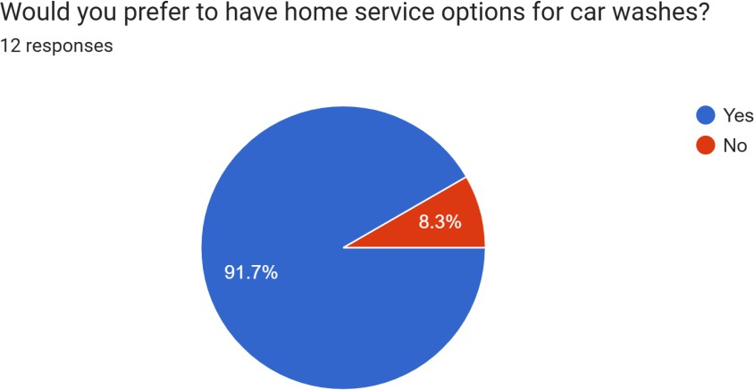

Figure 2.1: Prefer home service
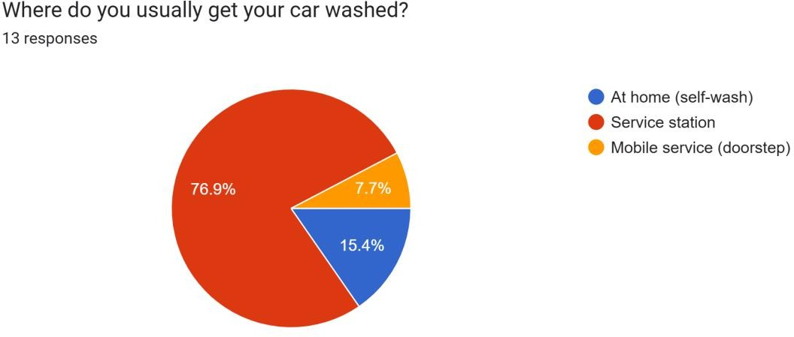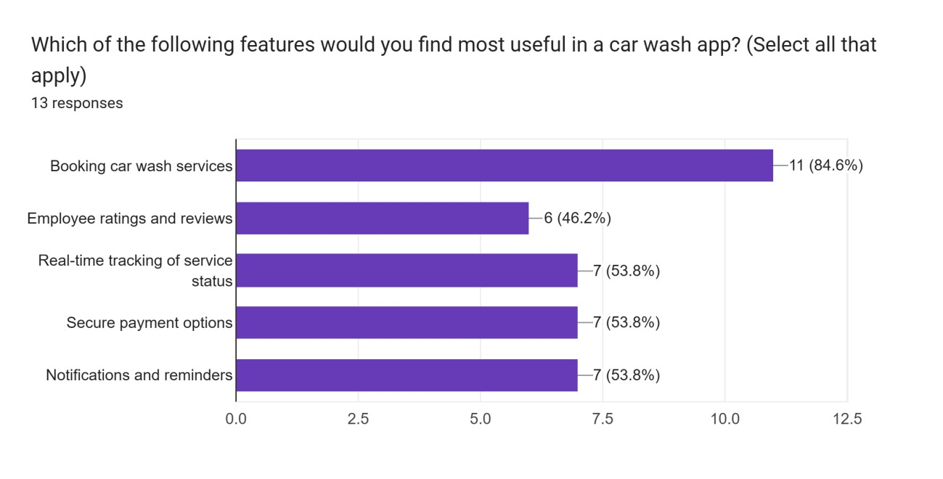
Figure 2.2: More Useful features

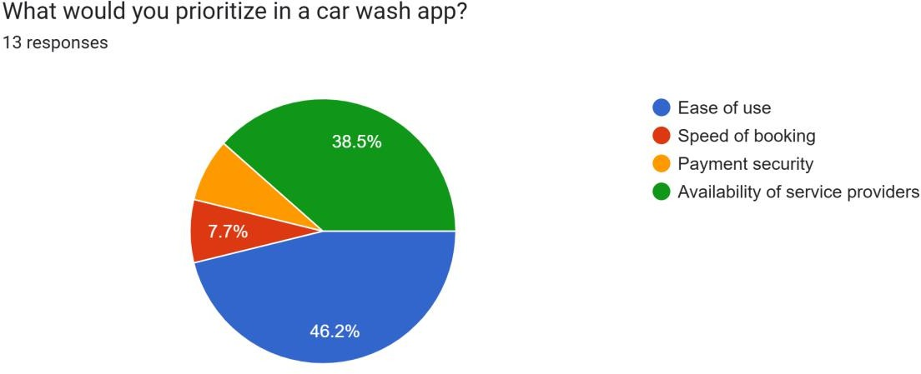
Figure 2.3: prioritize

2.2.1.1 Reason for Online Survey Technique

Online surveys are an effective way to gather extensive data from service station owners and customers regarding their preferences, challenges, and behaviors related to car wash services. This method enables us to reach a broad target audience, ensuring diverse perspectives from potential users of the Quick Wash App. The collected data helps in identifying user needs, service expectations, and pain points.

Furthermore, the survey results serve as a foundation for conducting more focused discussions with specific groups, such as individual service stations, car owners, and industry stakeholders. These in-depth conversations provide deeper insights into the obstacles and motivations that might not be fully captured through surveys.

By combining the quantitative data from surveys with the qualitative understanding gained from discussions, we achieve a comprehensive understanding of user requirements. This approach is vital for designing and refining the Quick Wash platform to ensure its effectiveness and user satisfaction.

2.2.1.1.1 Important Question

- What factors influence customers to choose specific car wash services?
- Do service stations face challenges in receiving consistent bookings? If so, what are they?
- Are customers aware of any apps that allow convenient request system and booking for car wash services?

2.2.1.1.2 Key Features

- What features do you consider essential for a platform like Quick Wash to improve customer and service station interactions?
- What tools or features would help service stations manage their employees and services more efficiently

2.2.1.1.3 Existing Software

- What systems or processes are currently used for managing car wash bookings and customer interactions?
- Can you describe or provide an example of your current workflow for handling customer bookings and services?

2.2.1.1.4 Authentication & Security

- How concerned are you about the security of your service station details, customer data, and payment information within the system?
- Would you prefer authentication options like OTP verification or multi-factor authentication for secure access?

2.3 Brainstorming
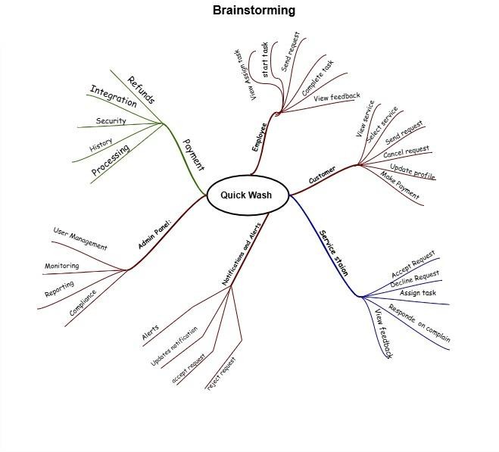
Figure 2.3: Brainstorming

2.4 Existing System
Table 2.1 | Existing System
Features &Services | Quick Wash App | Super Shine Auto Detailing | Mahir Company (Mr. Mahir) | Elite Services | Just Wash | Phoenix Wash | Clean Ride Pro | Turbo  Wash Express | Eco Auto Wash
Platform fee | ✓ | ✗ | ✗ | ✗ | ✗ | ✗ | ✗ | ✗ | ✗
Service Booking | ✓ | ✓ | ✓ | ✓ | ✓ | ✓ | ✓ | ✓ | ✓
Doorstep Service | ✓ | ✓ | ✓ | ✗ | ✓ | ✓ | ✓ | ✗ | ✓
Nearby Stations | ✓ | ✗ | ✓ | ✓ | ✗ | ✓ | ✓ | ✓ | ✗
Opportunities for Locals | ✓ | ✗ | ✗ | ✗ | ✗ | ✓ | ✓ | ✗ | ✓
Review & Rating | ✓ | ✓ | ✗ | ✓ | ✓ | ✓ | ✓ | ✓ | ✓
Notifications | ✓ | ✗ | ✗ | ✓ | ✗ | ✓ | ✓ | ✗ | ✓
Employee Management | ✓ | ✗ | ✗ | ✓ | ✗ | ✗ | ✓ | ✓ | ✓

2.5 Summary

The literature and market survey for Quick Wash focused on understanding existing systems and identifying gaps to establish the need for our app. By interviewing stakeholders and analyzing similar systems, we identified the lack of a streamlined request-based for customer and service stations. Our app introduces competitive for vehicle owners and service stations. The features ensure better service delivery, secure payment options, and real-time notifications, addressing the challenges of traditional service models. The research highlights how Quick Wash can bridge the gap, offering convenience and reliability for all stakeholders.

Chapter 3:
Requirement Analysis

Chapter 3

Requirement Analysis

3.1 Introduction

Within this chapter, we will go over the functional requirements for our project, “Quick Wash”. Prior to that, we will discuss the problem statements that we found when investigating the project concept. These functional needs were obtained from stakeholders and potential users using a variety of methods, including surveys, brainstorming sessions, and interviews. Analyzing the functional needs while taking the system’s performance, security, and user experience

3.2 Problem Scenarios

Table 3.1 | Problem Statement 1
Problem Statement-1
The Problem of | Limited availability of quick vehicle wash services
Affects | Customers.
The Result of Which | Causes cars to be ignored or receive infrequent maintenance because of time restrictions.
Benefits Of | Saving clients time and effort by offering at-home car wash services.

Table 3.2 | Problem Statement 2
Problem Statement-2
The Problem of | Absence of a coordinated service station management system for employment.
Affects | Manager, Customers.
The Result of Which | Results in cars being neglected or receiving irregular maintenance due to time constraints.
Benefits Of | Presents an employee management system that guarantees effective service order maximizes worker allocation.

Table 3.3 | Problem Statement 3
Problem Statement-3
The Problem of | High pricing for home-based car wash and cleaning services.
Affects | Customer.
The Result of Which | Home services adoption decreases while users return to traditional methods which lack convenience.
Benefits Of | This model helps develop an economical pricing structure enabled by mobile applications which reveal transparent prices thus making customers select options based on pricing which will be lower as compared to other platforms due to nearby station.

3.3 Functional Requirement

3.3.1 Request System for Home Services

Table 3.4 | Request System for Home Services
NO# | Functional  Requirements | Description | Priority
1 | Sending request Process | Customers will be able to send requests for the services they want to avail of for their vehicles (Location, Vehicle type, and Service type). These requests will be visible to the manager of the service stations. Service provider/Manager can accept/reject request based on the order’s location and staff’s availability. | High
2 | Cancellation of request | Users will be able to withdraw their request prior to the service provider accepting it. | High
3 | History of requests | Users will be able to see the history of past requests. | Low
4 | Notifications | Users will be able to obtain notifications on acceptance, updates, or cancellation of requests. | High

3.3.2 Employee Management System for Service Stations

Table 3.5 | Employee Management System for Service Stations
NO# | Functional  Requirements | Description | Priority
1 | Employee  Scheduling | Managers will be able to assign employees to service requests based on their availability. | High
2 | Task Assignment | Manager will be able to assign specific tasks to employees, such as washing or drying vehicles. | High
3 | Location Tracking | User will be able to track service providers location in real time during active service sessions. | High
4 | Notifications | User will be able to receive push notifications for updates. | High

3.3.3 User Registration

Table 3.6 | User Registration
NO # | Functional Requirements | Description | Priority
1 | Customer registration form | Customer will be able to fill out a user-friendly registration form with essential details like name, email and password. | High
2 | Service providers registration form | Service providers will have their own registration process with fields related to their role. | High
3 | Employee registration form | Employees will fill out required fields like name, Cnic and referral code for registration. | High
4 | Verification | System will be able to verify users to ensure authenticity during the registration process through their email confirmation, one time password and referral code. | High
5 | Recovery of Password | Users will be able to reset or recover their password using their registered phone number or email address. | High

3.3.4 Complaint & Feedback System

Table 3.7 | Complaint & Feedback
NO # | Functional Requirements | Description | Priority
1 | Complaint Submission | Customers will be able to submit complaints regarding service quality or issues. | Medium
2 | Complaint Tracking | Service provider/Manager will be able to track the status of submitted complaints and resolve them according to priority. | High
3 | Feedback System | Customer will be able to rate and review service providers after a completed service. | Medium

3.3.5 Admin Dashboard
Table 3.8 | Admin Dashboard
NO # | Functional Requirements | Description | Priority
1 | Admin Login | Admin can access the dashboard by logging in with secure credentials. | High
2 | View Registered Users | Admin can see a list of every user who has registered, including clients and service providers. | High

3.3.6 Customer

Table 3.9 | Customer
NO # | Functional Requirements | Description | Priority
1 | Request for Service | Customers will be able to order car wash services at their place, at desired time, choosing service type they want. | High
2 | Feedback | Customer will be able to provide feedback after the service is completed. | Low
3 | Customer support | User will be able consult app’s customer service. | High

3.3.7 Employee

Table 3.10 | Employee
NO # | Functional Requirements | Description | Priority
1 | Evaluate Assigned Tasks | Employees will be able to see the tasks they have been given for the day. | High
2 | Navigation with google Maps | Employees will be able to navigate efficiently by using google maps to follow directions to the customer’s location. | High
3 | Task Status Recognition | Employees will simply need to confirm work completion with a simple “Completed” button. | High

3.4 Summary

As shown above, we have written all the functional requirements using technique like interviewing and brainstorming. Moreover, we have written Problem Statement and Proposed Solution.

Chapter 4:
System Design

Chapter 4

System Design

4.1 Introduction

System design involves defining the structure, responsibilities, and interactions of the components of the software to meet user requirements. The design phase translates the functional requirements into a blueprint for the system. In this chapter, we present the design diagrams for the Quick Wash app, including architectural design, use case design, and activity design. These diagrams depict the workflow, technical design, and interactions of various components within the system, illustrating how Quick Wash will function efficiently to meet user need.

4.2 Architecture Diagram

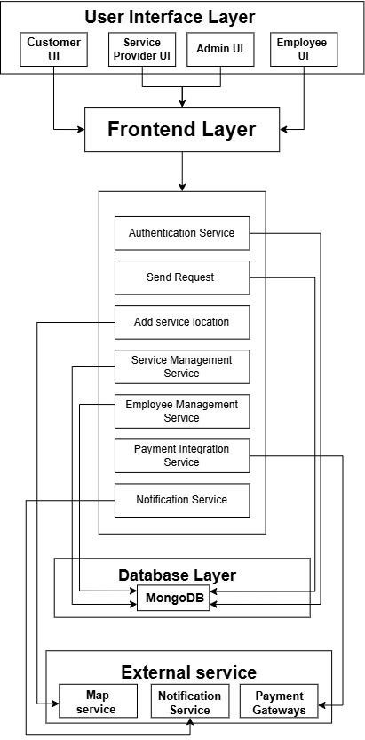
Figure 4.1: Architecture Diagram

4.3 Detailed Design

4.3.1 Use Case Diagram

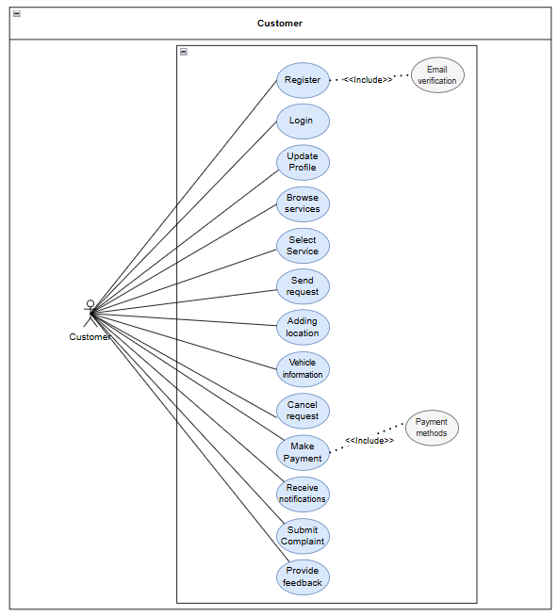
Figure 4.2: Customer Use Case

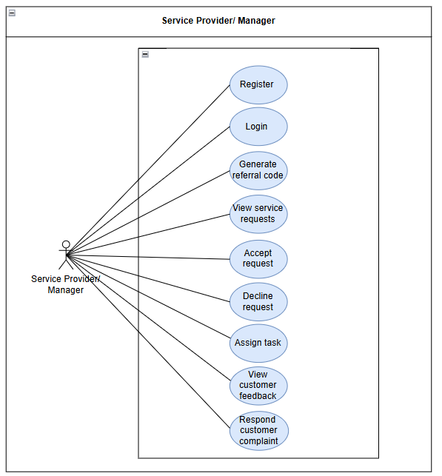
Figure 4.3: Service Provider/ Manager Use Case
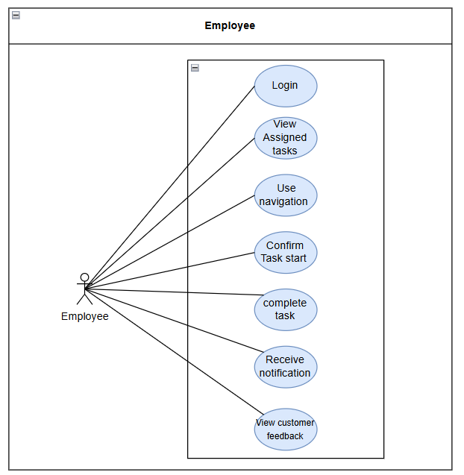
Figure 4.4: Employee Use Case

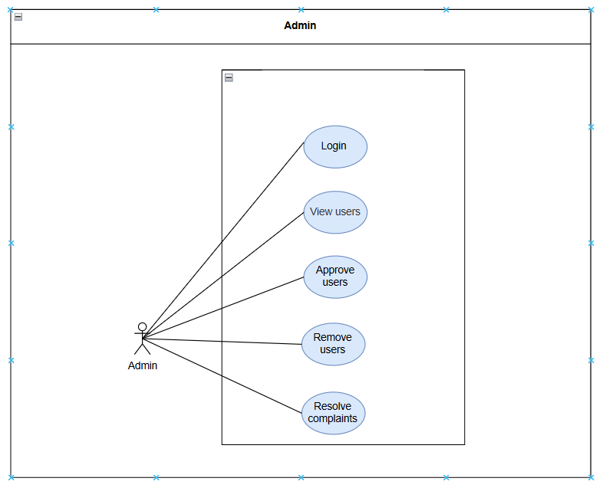
Figure 4.5: Admin Use Case

4.3.2 Use Case Fully Dressed Format

4.3.2.1 Customer

Table 4.1 |UC1 – Registration
Use case ID: | UC-001
Use Case name | Registration
Actors: | Customer
Type: | Primary
Description: | A new customer to register on the Quick Wash platform
Preconditions: | Customer has an active email address for verification.
Postcondition: | The customer account is created successfully.
Normal Flow:
  Actor Actions: | System Response:
  1. Customer opens the app and selects the "Create account as customer" option. | 2. The system displays a registration form with fields for basic information, such as name, email & password.
  3. Customer fills out the registration form and submits it. | 4. The system validates the entered information and sends an OTP (One-Time Password) to customer's email for verification.
  5. Customer enters the OTP received on their device. | 6. The system verifies the OTP; it proceeds to create the customer account.
   | 7. System confirms successful registration and directs the customer to the login screen.
Alternative Flow: | A1: If the customer doesn’t provide complete information or missing information the system displays an error message, complete the required field before proceeding.  A2: If the OTP is incorrect or not entered the system prompts enter the complete verification code.
Table 4.2 |UC2 – Login
Use case ID: | UC-002
Use Case name: | Login
Actors: | Customer
Type: | Primary
Description: | Registered customer to log in to the Quick Wash application.
Preconditions: | The customer has a valid username (email) and password.
Postcondition: | The customer successfully logs into their account and gains access to the application's main features.
Normal Flow:
  Actor Actions: | System Response:
  1. Customer opens the app and selects the "Login" option. | 2.The system displays the login screen with fields for username (email) and password.
  3. Customer enters their email & password. | 4. The system validates the entered credentials.
   | - Credentials are correct, the system login the customer into their account.
   | 6. The system directs the customer to the home screen/dashboard.
Alternative Flow: | A1: If the customer enters incorrect credentials, the system displays an error message and prompts the customer to try again.  A2: If the customer has not yet registered, the system prompts “no customer found with these credentials”.

Table 4.3 |UC3 – Manage Profile
Use case ID: | UC-003
Use Case name: | Manage Profile
Actors: | Customer
Type: | Primary
Description: | A customer to view and update their profile information within the Quick Wash application.
Preconditions: | The customer is logged into the Quick Wash app
Postcondition: | The customer's profile information is successfully updated in the system.
Normal Flow:
  Actor Actions: | System Response:
  1. Customer navigates to the "Profile" section from the dashboard. | 2. The system displays the customer’s current profile  information (e.g., name, email.)
  3. Customer selects the "update" option to modify their profile details. | 4. The system allows the customer to update fields such as name, email, etc.
  5. Customer enters the new information and submits the changes. | 6. The system validates the updated information and saves the changes in the database.
Alternative Flow: | A1: If the customer enters incomplete information (e.g., incomplete email field), the system displays an error message “server error”.

Table 4.4 |UC4 – Browse Service
Use case ID: | UC-004
Use Case name: | Browse Services
Actors: | Customer
Type: | Primary
Description: | A customer browses through the car wash services offered by Quick Wash. The customer can view details about each service, including pricing and description.
Preconditions: | The customer is logged into the Quick Wash app
Postcondition: | The customer has successfully viewed the services and selected a service (if desired).
Normal Flow:
  Actor Actions: | System Response:
  1. Customer navigates to the "Request a service" section from the main menu. | 2. The system displays a list of car wash services, including descriptions, prices, and service categories (e.g., basic wash, full detailing).
  3. Customers view the car wash services.
  4. Customers Browse the car wash services.

Table 4.5 |UC5 – Select Service
Use case ID: | UC-005
Use Case name: | Select Service
Actors: | Customer
Type: | Primary
Description: | A customer selects a car wash service in the Quick Wash app, including specifying service preferences.
Preconditions: | The customer is logged into the Quick Wash app.  The customer has navigated to the service screen.
Postcondition: | The service request is successfully submitted, and the customer receives confirmation or pending status.
Normal Flow:
  Actor Actions: | System Response:
  1. Customer selects a service from the list to request. | 2. The system displays the service details.
  3. Customer confirms the service request details and submits the request. | 4. The system saves the request and assigns request to service provider displaying an alert message  “Request sent to provider”.
   | 5. System sends a confirmation message or notification to the service provider with request details.
Alternative Flow: | A1. If the customer decides to cancel the request submitted, the system discards the request and returns it to the previous screen.

Table 4.6 |UC6 – Adding Location
Use case ID: | UC-006
Use Case name | Adding location
Actors: | Customer
Type: | Primary
Description: | Customer provides location where they are currently, which allows the service providers to get to the right place.
Preconditions: | The customer has selected a car wash service from the service list (referring to UC-005: Select service).  The customer is at the screen where location is required.
Postcondition: | The service request is successfully submitted, and the customer receives confirmation or pending status.
Normal Flow:
  Actor Actions: | System Response:
  1. Customer navigates to screen where location is required during the service request process. | 2. The system displays a field asking the customer to add their location.
  3. Customers add the location. | 4. System validates the added location.
Alternative Flow: | A1. Customer enters an invalid or incomplete address; the system responds with the “error fetching address”.

Table 4.7 |UC7 – Adding vehicle information
Use case ID: | UC-007
Use Case name: | Adding vehicle information
Actors: | Customer
Type: | Primary
Description: | The customer provides the car model and year, with this information the service provider is guaranteed to have the right information about the vehicle.
Preconditions: | The customer has selected a car wash service from the service list (referring to UC-005: Select service).  The system is requesting vehicle details before confirming the service request.
Postcondition: | The customer’s vehicle information is successfully added.
Normal Flow:
  Actor Actions: | System Response:
  1. Customer navigates to screen where is vehicle information is required during the service request process. | 2. The system displays a field asking the customer to add their vehicle information.
  3. Customers add the Vehicle information. | 4. System validates Vehicle information.
Alternative Flow: | A1. The customer enters incomplete information; the system responds with the incomplete information.

Table 4.8 |UC8 – Send Request
Use case ID: | UC-008
Use Case name: | Send request
Actors: | Customer
Type: | Primary
Description: | A customer places a request for a car wash service through the Quick Wash app, for the selected service.
Preconditions: | The customer is logged into the Quick Wash app.  The customer has selected a service to request on and reviewed the service details.
Postcondition: | The request is successfully placed, and the customer is notified when a service station accepts or rejects the request.
Normal Flow:
  Actor Actions: | System Response:
  1. Customer navigates to the services section. | 2. The system displays a request form where the customer can enter necessary details (e.g. address, vehicle information).
  3 Customer clicks on the "Send request" option. | 4. The information entered is verified by the system (e.g., making sure all required fields are filled in).
   | 5. The request is noted by the system and sent to the appropriate service provider for review.
   | 6. System notifies the customer that the request has been successfully sent.
Alternative Flow: | A1. If any field is empty or has invalid information, the system displays an error message to correct the information before submitting it.

Table 4.9 |UC9 – Cancel Request
Use case ID: | UC-009
Use Case name: | Cancel Request
Actors: | Customer
Type: | Primary
Description: | A customer can cancel request they placed for a car wash service on Quick Wash.
Preconditions: | The customer is logged into the Quick Wash app.  The customer has an active request that has not yet been accepted by a service station
Postcondition: | The request is successfully canceled.
Normal Flow:
  Actor Actions: | System Response:
  1. Customer navigates to their active request and cancels the request they want to cancel. | 2. The system displays the request details and provides an option to cancel the request.
  3. Customer confirms the cancellation. | 4. The system cancels the request and updates the status to "Cancelled."
   | 5. System sends a confirmation notification to the customer, confirming the request cancellation.
Alternative Flow: | A1. If the request has already been accepted, the system prevents cancellation and notifies the customer that the request cannot be cancelled.

Table 4.10 |UC10 – Receive Notification
Use case ID: | UC-0010
Use Case name: | Receive Notifications
Actors: | Customer
Type: | Primary
Description: | A customer receives notifications related to their requests, bookings, and service status updates.
Preconditions: | The customer is logged into the Quick Wash app and has notifications enabled.
Postcondition: | The customer receives relevant notifications in real-time
Normal Flow:
  Actor Actions: | System Response:
   | 1. System detects a new activity related to the customer’s requests (e.g., request accepted, service in progress).
   | 2. The system sends a push notification or in-app alert to the customer with details of the update.
  3. Customer clicks on the notification to view more details. | 4. The system redirects the customer to the relevant section (e.g. send request, booking status).

Table 4.11 |UC11 – Submit Complaint
Use case ID: | UC-0011
Use Case name: | Submit Complaint
Actors: | Customer
Type: | Primary
Description: | A customer submits a complaint about a service or experience through the Quick Wash app.
Preconditions: | The customer is logged into the Quick Wash app.
Postcondition: | The complaint is successfully submitted, and the customer receives confirmation.
Normal Flow:
  Actor Actions: | System Response:
  1. Customer navigates to the "Submit Complaint." | 2. The system displays a complaint form with fields for entering details and selecting the type of complaint (e.g., service quality, pricing).
  3. Customer fills out the complaint form and submits it. | 4. The system records the complaint and sends a confirmation notification to the customer.
   | 5. System forwards the complaint to the relevant service station or support team for review.
Alternative Flow: | A1. If the customer does not provide enough details, the system prompts them to add more information before submission.

Table 4.12 |UC12 – Provide Feedback
Use case ID: | UC-0012
Use Case name: | Provide Feedback
Actors: | Customer
Type: | Primary
Description: | A customer provides feedback after receiving a car wash service in the Quick Wash app
Preconditions: | The customer is logged into the Quick Wash app.  The employee has completed a service.
Postcondition: | The feedback is submitted successfully and recorded for future reference.
Normal Flow:
  Actor Actions: | System Response:
  1. Customer receives a prompt to provide feedback on the completed service. | 2. The system displays a feedback form with options for rating the service and adding comments.
  3. Customer rates the service and optionally adds comments about their experience. | 4. The system records the feedback and saves it under the customer’s service history.
   | 5. System confirms the feedback submission and updates the service station's ratings.
Alternative Flow: | A1. If the customer chooses to skip the feedback, the system records the decision and does not prompt further.

4.3.2.2 Service Provider/Manager

Table 4.13 |UC13 – Registration
Use case ID: | UC-13
Use Case name | Registration
Actors: | Service provider
Type: | Primary
Description: | A service provider registers on Quick wash app by providing service station name, contact number, city, address.
Preconditions: | Service provider has an active email for verification.
Postcondition: | The service provider account is created successfully, allowing the user to access further features of the application.  The service provider can log in to access their dashboard and manage their services.
Normal Flow:
  Actor Actions: | System Response:
  1. Service provider opens app & selects "Register as service provider" option. | 2. The system displays a registration form with the fields of service station name, contact number, address, city, e-mail, referral code and password.
  3. Service provider fills out registration form and submits it. | 4. System validates enter information and sends an OTP (One-Time Password) to service provider's email for verification.
  5. Service provider enters OTP received on their device. | 6. The system verifies the OTP,  creates service provider’s account.
   | 7. System confirms the successful registration and directs the service provider to the login screen.
Alternative Flow: | A1: If service provider doesn’t provide complete information or missing information (e.g., missing station name), system displays an error message, complete required field before proceeding.  A2: If the OTP is incorrect or not entered the system prompts enter the complete verification code.

Table 4.14 |UC14 – Login
Use case ID: | UC-14
Use Case name | Login
Actors: | Service provider
Type: | Primary
Description: | Service provider is registered to log in to Quick Wash App.
Preconditions: | Service provider has already registered on Quick Wash platform  Service provider has a valid number or username and password.
Postcondition: | The service provider successfully logs into their account and gains access to the application's main features.
Normal Flow:
  Actor Actions: | System Response:
  1. Service provider opens app & selects the Login option. | 2.The system displays the login  screen with fields for email and password.
  3. Service provider enters their email and password. | 4. The system validates the entered credentials.
   | The system logs the service provider into their account.
   | 7. The system directs the service provider to the home screen/dashboard
Alternative Flow: | A1: If the service provider enters incorrect credentials, the system displays an error message “No provider found”.  A2: If the service provider enters incorrect credentials, the system displays an error message and prompts the service provider to try again.  A3: If the service provider has not yet registered, the system prompts “no provider found with these credentials”.

Table 4.15 | UC15 – Forgotten Password
Use case ID: | UC-0015
Use Case name | Forgotten Password
Actors: | Admin, Service provider/Manager, Customer
Type: | Primary
Description: | The users failed to login due to the forgotten password navigates to the forgot password screen.
Preconditions: | The system must be operational.  User must have a phone number/E-mail registered on platform.
Postcondition: | The user resets their password successfully and regains access to their account.
Normal Flow:
  Actor Actions: | System Response:
  1. User selects forgotten password option on the login screen.
  2.Users enter their registered e- mail/phone number. | 3.The system verifies the login credentials.
  4.User clicks submit button. | 5.System validates the  entered e-mail/phone number.
   | 6.System sends recovery link to user
  7.User clicks on recovery link to gain access to the reset password page.
  8.User sets a new password & confirms it. | 9.System updates new password & sends notification
Alternative Flow: | A1: If the user enters an unregistered e-mail/phone number. System displays message no user exists with this e-mail/phone number.

Table 4.16 | UC16 – View Service Request
Use case ID: | UC-0016
Use Case name | View service requests
Actors: | Service provider
Type: | Primary
Description: | The service provider manages the list of upcoming service requests. These include such things as customer information, requested service type, location and status (e.g.: pending, in progress, completed).
Preconditions: | There are service requests available in the system for service provider.
Postcondition: | Service provider views the list of service requests & their status.  The service provider can take actions on the requests, such as accepting, assigning employees, or updating the status.
Normal Flow:
  Actor Actions: | System Response:
  - 1. Service provider logs into the Quick wash app and navigates “to the notifications” section. | 2.The system displays dashboard showing the list of service requests including customer’s name, requested service type (e.g.: full detailing, exterior wash) location, price and preferences.
  - Service provider selects a specific request to view detailed information such as customer contact Details  vehicle information (make, model, etc.) Scheduled time for service. | 4. The system displays detailed information.
Alternative Flow: | A1: Service provider navigates to the “service requests” section.  System displays a message “No service requests available at the moment”.

Table 4.17 | UC17 – Accept request
Use case ID: | UC-0017
Use Case name | Accept request
Actors: | Admin, Service provider/Manager, Customer
Type: | Primary
Description: | A service request from customer is reviewed & accepted by service provider/Manager. Service provider/Manager verifies availability when it is approved preparing for service delivery.
Preconditions: | Service request is available in system & assigned to provider’s station.  Service provider has the necessary staff & resources to fulfill request.
Postcondition: | The request is “Accepted”.  Customer is notified of the acceptance.  The service station prepares for service delivery.
Normal Flow:
  Actor Actions: | System Response:
  1. Service provider/Manager logs into the Quick wash app & navigates “to the service requests” section. | 2.The system displays a list of pending requests requiring assignment.
  3. The service provider/Manager reviews the list of pending requests & selects a specific request.
  4. Service provider/Manager
  Verifies the customer detail.
  5. Service provider/Manager clicks on the “accept request” button. | 6. System updates status as request Accepted

Table 4.18 | UC18 – Decline request
Use case ID: | UC-18
Use Case name | Decline request
Actors: | Service provider/Manager
Type: | Primary
Description: | A service request from a customer is reviewed and declined by the service provider/Manager if he doesn’t have the resources to fulfill that fulfill that order.
Preconditions: | The service provider/Manager is logged has logged into app.  Service request is available in system & assigned to provider’s station.
Postcondition: | The request is “Declined”.  The System removes the request from the list of service provider/Manager.
Normal Flow:
  Actor Actions: | System Response:
  1. Navigates “to the service requests” section. | 2.The system displays a list of pending requests requiring assignment.
  3. Service provider/Manager reviews the list of pending requests and selects a specific request.
  4. Service provider/Manager verifies the customer’s details (contact information, Vehicle details Service type and location).
  5. Service provider/Manager clicks on the “decline request” button. | 6. The system updates the status as request declined.
Table 4.19 | UC19 – Assign task
Use case ID: | UC-0019
Use Case name | Assign task
Actors: | Service provider/Manager
Type: | Primary
Description: | A specific service request is assigned by the manager to an employee who is available to perform the task. This guarantees timely service delivery and efficient task management.
Preconditions: | There are service requests available in the system that require assignment.  Employees are registered in the system and their availability is displayed.
Postcondition: | Task is assigned to employee successfully and employee has been notified.
Normal Flow:
  Actor Actions: | System Response:
  1. Navigates “to the service requests” section. | 2.The system displays a list of pending requests requiring assignment.
  The Manager selects a specific request | The system displays the list with details like: Customer (Name, Contact, Service type and location) Preferred time.
  5. Manger clicks on the  “Assign task”. | 6. System displays list of available employees.
  7. Manager selects an
  employee and confirms the assignment.
Alternative Flow: | A1: Manager tries to assign the task, but no employee is available. System displays a message “No employees are available”.

Table 4.20 | UC20 – View customer feedback
Use case ID: | UC-0020
Use Case name | View Customer Feedback
Actors: | Service provider/Manager
Type: | Primary
Description: | A customer’s comment about completed services is accessed and reviewed by the service provider/manager. In order to help the service provider/manager improve the quality of their offerings, this feedback contains ratings, remarks or suggestions for improvement.
Preconditions: | Feedback is submitted by the customer.
Postcondition: | The service provider effectively evaluates feedback to pinpoint areas for improvement as well as trends and strengths.
Normal Flow:
  Actor Actions: | System Response:
  1.Service provider/Manager navigates to feedback section. | 2.The system displays a list of completed tasks with details such as:(Task ID, Customer name, Date of service (e.g. detailing exterior wash)
  3.Service provider/Manager selects a specific task to view feedback. | 4.The system displays: Rating (e.g. 1-5) Customer comments (e.g. “Great service”) etc.
  5.Service provider/Manager analyzes the feedback.
Alternative Flow: | A1: Service provider/Manager navigates to feedback section. System displays the message “No feedback available”.

Table 4.21 | UC21 – Respond customer complaint
Use case ID: | UC-0021
Use Case name | Respond customer complaint
Actors: | Service provider/Manager, Customer
Type: | Primary
Description: | Service provider/Manager ensures that customer satisfaction is not being compromised so they evaluate their complaints & respond to them.
Preconditions: | The complaint is registered in the complaints section of the system.
Postcondition: | A response or solution is provided for the customer’s complaint.
Normal Flow:
  Actor Actions: | System Response:
  1. Navigates “to the Customer Complaints” section. | 2.The system displays a list of complaints.
  3.Service provider/Manager selects specific complaint to view the detailed information related to it such as: (Customer name, Contact detail, Service request id and complaint description).
  4. Service provider/Manager  reviews the complaint details. | .
  5. Service provider/Manager generates a response which includes:
  - Apology and acknowledgement for the issue customer has faced.
  - A proposed solution.
  - A request for additional information if needed.
  6. Service provider/Manager submits the response. | 7. System updates the complaint status.

4.3.2.3 Employee

Table 4.22 | UC22 – Login
Use case ID: | UC-0022
Use Case name | Login
Actors: | Employee
Type: | Primary
Description: | The employee logs into the Quick Wash application to access their assigned tasks and system features.
Preconditions: | The employee is registered through the manager in the system and has valid login credentials.
Postcondition: | The employee is successfully logged in, and the dashboard is displayed.
Normal Flow:
  Actor Actions: | System Response:
  1. The employee opens the Quick Wash app. | 2. The system displays the login screen.
  3. The employee enters their username and password. | 4. The system verifies the login credentials.
  5. The employee clicks the 'Login' button. | 6. The system grants access and redirects to the employee's dashboard.
Alternative Flow: | A1: If the employee enters incorrect login credentials, the system displays an error message and prompts to re-enter credentials  A2: If the account is locked due to multiple failed login attempts, the system displays a 'Contact Admin' message.

Table 4.23 | UC23 – View assign task
Use case ID: | UC-0023
Use Case name | View assign task
Actors: | Employee
Type: | Primary
Description: | The employees view their list of assigned tasks, including service details and locations.
Preconditions: | The employee is logged into the Quick Wash app.
Postcondition: | The employee views the list of tasks assigned to them.
Normal Flow:
  Actor Actions: | System Response:
  1.The employee navigates  to the 'Tasks' section. | 2.The system displays the assigned tasks.
  3.The employee selects a specific task. | 4.The system shows task details such as customer  name, service type, and location.
Alternative Flow: | A1: If no tasks are assigned, the system displays a 'No tasks assigned' message.

Table 4.24 | UC24 – Use Navigation
Use case ID: | UC-0024
Use Case name | Use Navigation
Actors: | Employee
Type: | Primary
Description: | The employee uses the navigation system to locate the customer's address for service.
Preconditions: | The employee is logged in and has selected a task.
Postcondition: | The employee is directed to the customer's location.
Normal Flow:
  Actor Actions: | System Response:
  1. The employee clicks the 'Navigate' button on a task. | 2.The system opens the navigation feature and  displays the customer's location.
  3. The employee starts navigation. | 4. The system provides step- by-step directions.
Alternative Flow: | A1: If the location is invalid, the system displays an error message and prompts the employee to contact the service station.

Table 4.25 | UC25 – Confirm task start
Use case ID: | UC-0025
Use Case name | Confirm Task Start
Actors: | Employee
Type: | Primary
Description: | The employee confirms the start of a task to notify the system and customer.
Preconditions: | The employee is logged in and has selected a task.
Postcondition: | The task status is updated to 'In Progress.
Normal Flow:
  Actor Actions: | System Response:
  1. The employee selects the assigned task. | 2. The system displays task details.
  3. The employee clicks 'Start Task.' | 4. The system updates the task status to 'In Progress'  and notifies the customer.

Table 4.26 | UC26 – Complete Task
Use case ID: | UC-0026
Use Case name | Complete Task
Actors: | Employee
Type: | Primary
Description: | Employee marks a task as completed after finishing the service.
Preconditions: | The task is in 'In Progress' status.
Postcondition: | Task status is updated to 'Completed,' and customer is notified.
Normal Flow:
  Actor Actions: | System Response:
  1.Employee select the complete task. | 2.The system displays task detail.
  3.Employee clicks 'Complete Task.' | 4. System updates task status to 'Completed' & notifies the customer.

Table 4.27 | UC27 – Receive Notification
Use case ID: | UC-0027
Use Case name | Receive Notifications
Actors: | Employee
Type: | Primary
Description: | Employee receives notifications for assigned tasks and updates.
Preconditions: | The employee is logged into the system.
Postcondition: | Notifications are successfully delivered and displayed.
Normal Flow:
  Actor Actions: | System Response:
  1.The employee opens the notifications section. | 2. The system displays recent notifications.
Alternative Flow: | A1: If there are no notifications, the system displays 'No new notifications

Table 4.28 | UC28 – View Customer Feedback
Use case ID: | UC-0028
Use Case name | View Customer Feedback
Actors: | Employee
Type: | Primary
Description: | The employee views feedback from customers for completed tasks.
Preconditions: | The employee is logged in.  Feedback exists for completed tasks
Postcondition: | Feedback is displayed to the employee
Normal Flow:
  Actor Actions: | System Response:
  1.The employee navigates to the 'Feedback' section. | 2.The system displays  customer feedback for completed tasks.
Alternative Flow: | A1: If no feedback exists, the system displays 'No feedback available.

4.3.2.4 Admin

Table 4.29 | UC29 – Login
Use case ID: | UC-0029
Use Case name | Login
Actors: | Admin
Type: | Primary
Description: | The admin logs into the Quick Wash application to oversee service providers, keep an eye on customers' complaints and make sure that the platform runs smoothly, among other system-wide tasks.
Preconditions: | The admin has valid login credentials (Username and Password)
Postcondition: | The admin has successfully logged into the system and accesses the admin dashboard to perform administrative tasks.
Normal Flow:
  Actor Actions: | System Response:
  1. The admin opens the Quick Wash app. | 2.The system displays the login screen with the fields of username and  password.
  3.The admin enters  their username and password. | - The system verifies the login credentials.
  5. The admin clicks the 'Login' button. | 6. The system grants access  and redirects to the admin's dashboard.
Alternative Flow: | A1: If the admin enters incorrect login credentials, the system displays an error message and prompts to re-enter credentials.

Table 4.30 | UC30 – View Users
Use case ID: | UC-0030
Use Case name | View users
Actors: | Admin
Type: | Primary
Description: | The list of registered users and their information, such as their role, activity history, and current status are viewed by the admin.
Preconditions: | The admin logs into the system.  The users are registered in the system.
Postcondition: | Admin successfully views the user details.
Normal Flow:
  Actor Actions: | System Response:
  1. The admin navigates to the view user section | 2. The system displays the users list with details.
  3.The admin selects a user to view detailed information. | 4.System displays the detail of that user like  - Name  - Email/Phone number  - Role  - Account status
Alternative Flow: | A1: If the admin enters incorrect login credentials, the system displays an error message and prompts to re-enter credentials.

Table 4.31 | UC31 – approve Users
Use case ID: | UC-0031
Use Case name | Approve Users
Actors: | Admin
Type: | Primary
Description: | To provide access to the platform, the admin examines and authorizes pending users' registrations requests.
Preconditions: | The admin logged into the system.  There are pending users' registration requests.
Postcondition: | After being authorized the chosen user account is enabled.
Normal Flow:
  Actor Actions: | System Response:
  1. The admin navigates to manage user section. | 2. The system displays the list of pending user registration requests.
  3.Admin selects specific user requests to review. | 4.The system displays user registration details.
  5.Admin approves the user request.

Table 4.32 | UC32 – Remove User
Use case ID: | UC-0032
Use Case name | Remove Users
Actors: | Admin
Type: | Primary
Description: | The admin either permanently removes the account or temporarily deactivates it.
Preconditions: | The admin is logged into the system.  There are active users in the database.
Postcondition: | The selected user is either deactivated or permanently removed.
Normal Flow:
  Actor Actions: | System Response:
  1.The admin navigates to manage user section. | 2.The system displays a list of active users.
  3.Admin selects specific user to remove. | 4.System prompts the admin to choose between  deactivate or delete the account.
Alternative Flow: | A1: If the admin cancels the removal process the system will discard that process and send the admin to the previous screen.

Table 4.33 | UC33 – Resolve Complaint
Use case ID: | UC-0033
Use Case name | Resolve complaint
Actors: | Admin
Type: | Primary
Description: | The admin resolves the user complaints submitted via Quick Wash platform and contacts the associated parties if necessary.
Preconditions: | The admin is logged into the system.  At least one complaint is registered.
Postcondition: | The complaint status is updated to resolved.
Normal Flow:
  Actor Actions: | System Response:
  1.The admin navigates to the complaints section in the dashboard | 2.The system displays a list of complaints categorized such as  - In progress  - Pending  - resolved
  3.Admin selects specific complaints from the list. | 4.System shows the detailed information related to selected complaints.
  5.Admin resolves the complaint and updates the status and changes to resolved. | 6.System updates the status.
   | 7.System notifies the user about the complaint being resolved.
Alternative Flow: | A1: If the information is very limited then the admin can ask for more info related to that issue and the system will send a request to the user for further details.

4.3.3 Activity Diagram

4.3.3.1 Customer

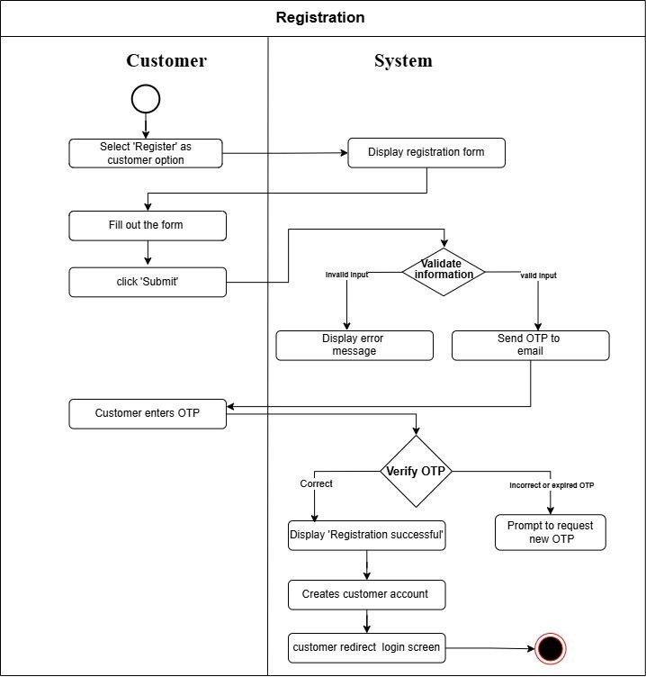

Figure 4.6: Registration

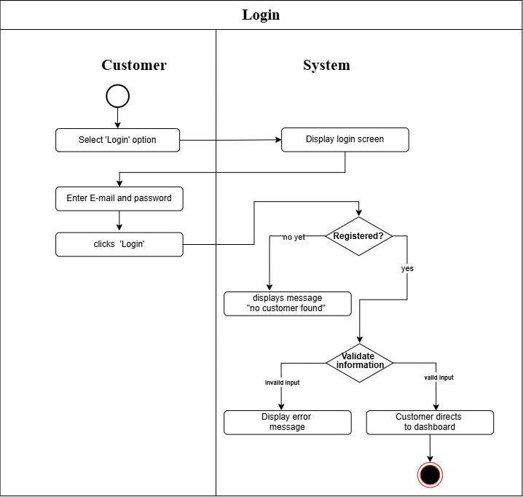

Figure 4.7: Login
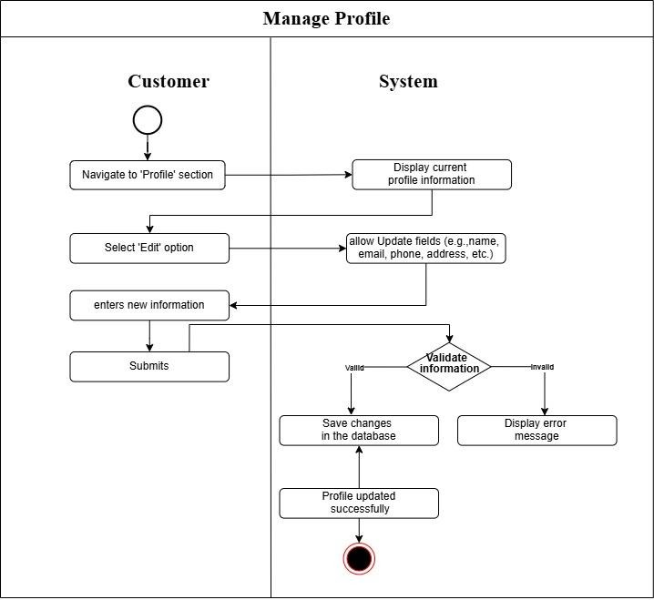
Figure 4.8: Manage Profile

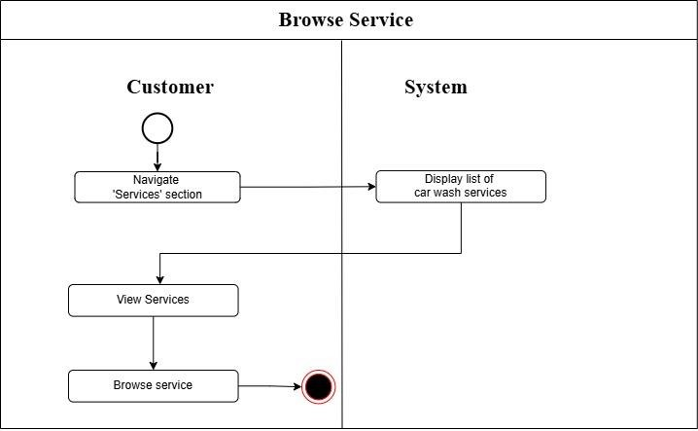
Figure 4.9: Browse Service
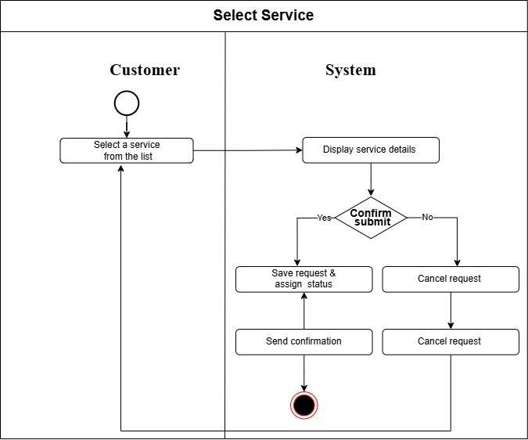
Figure 4.10: Select Service

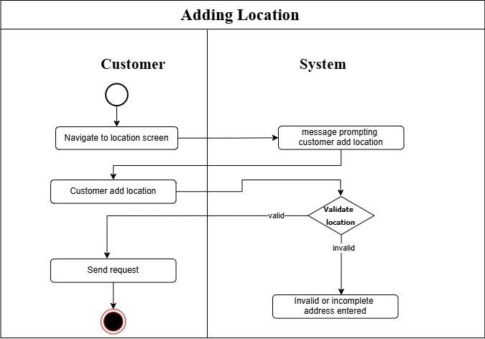
Figure 4.11: Adding Location
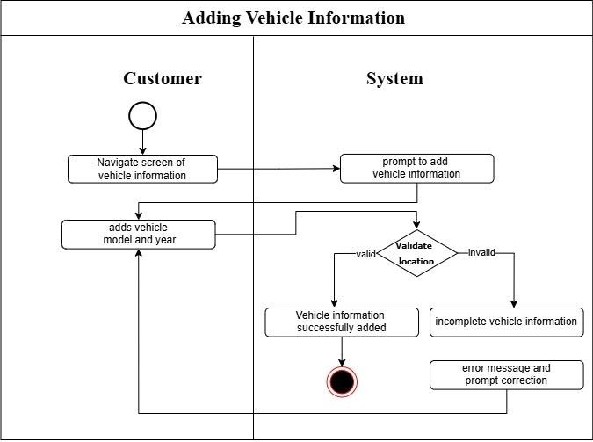
Figure 4.12: Adding Vehicle Information

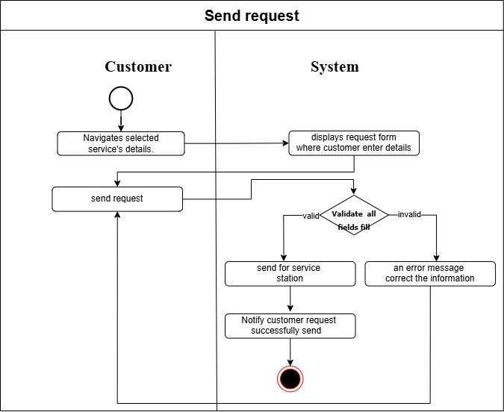
Figure 4.13: Send Request
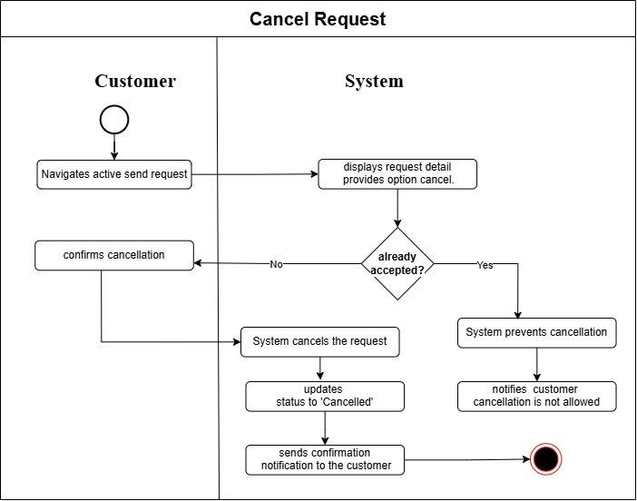
Figure 4.14: Cancel Request

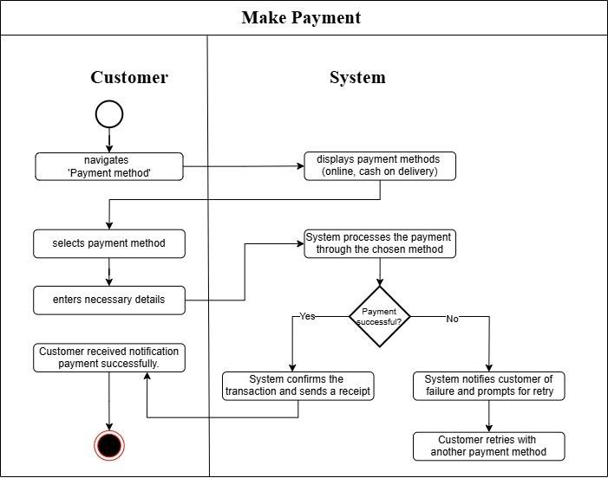
Figure 4.15: Make Payment
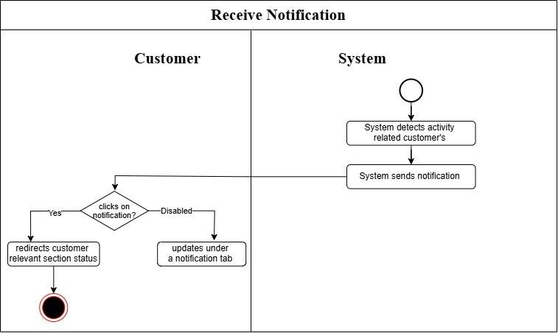
Figure 4.16: Receive Notification

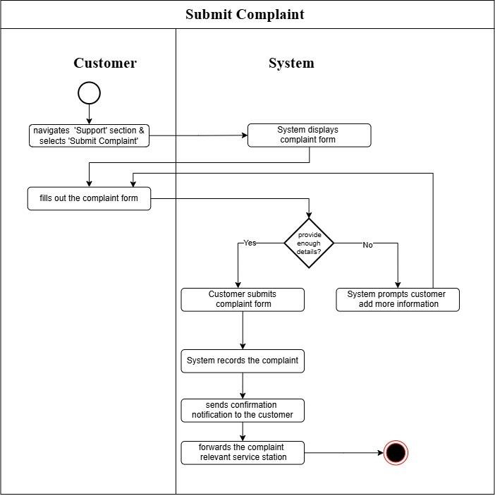
Figure 4.17: Submit Complaint

4.3.3.2 Service Provider/Manager

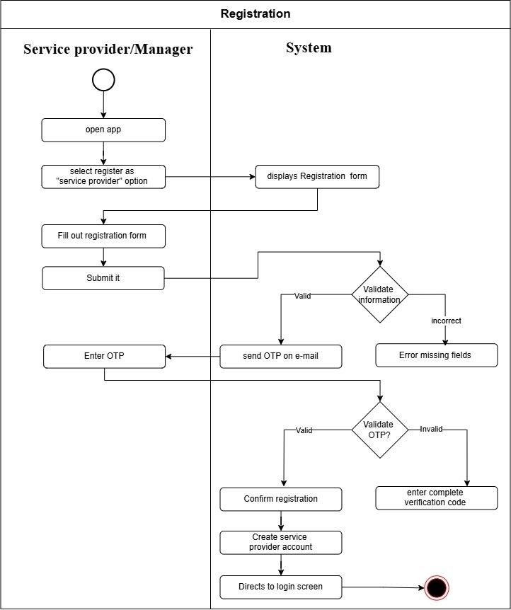
Figure 4.18: Registration
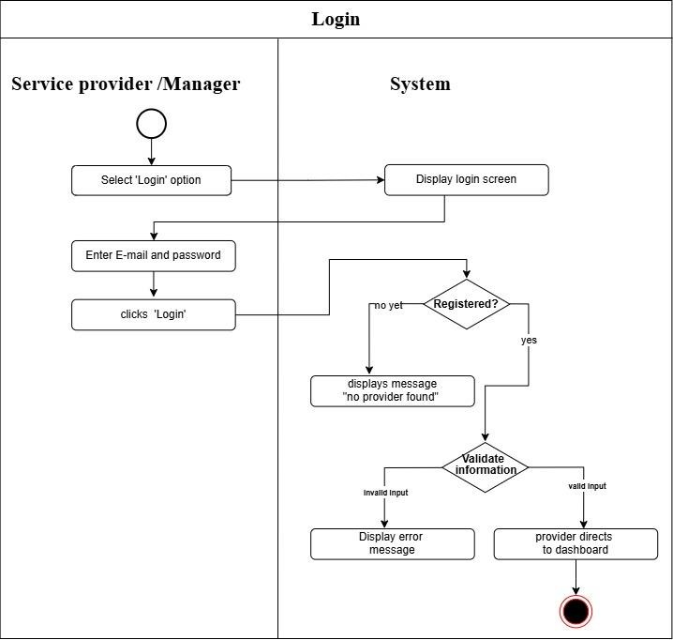
Figure 4.19: Login
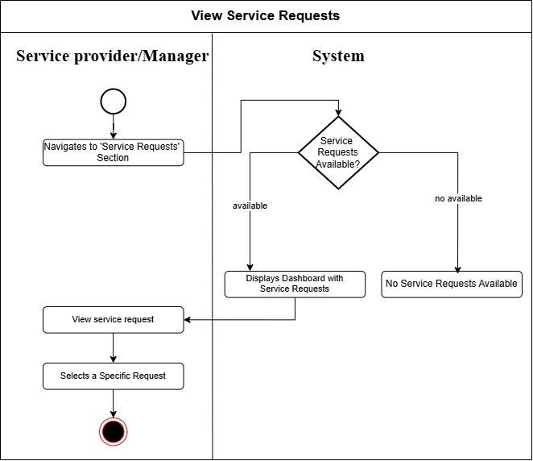
Figure 4.20: View Service Request

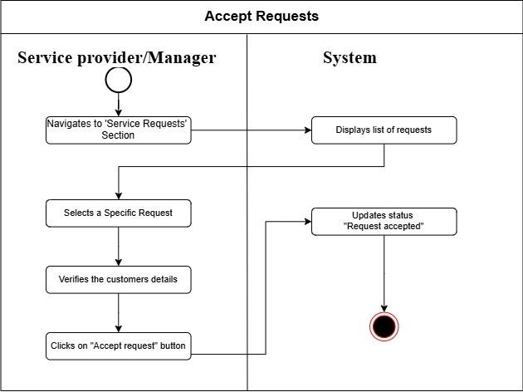
Figure 4.21: Accept Request
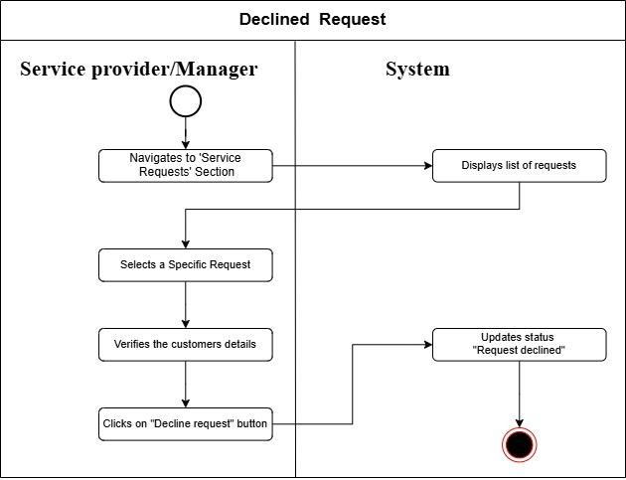
Figure 4.22: Declined Request

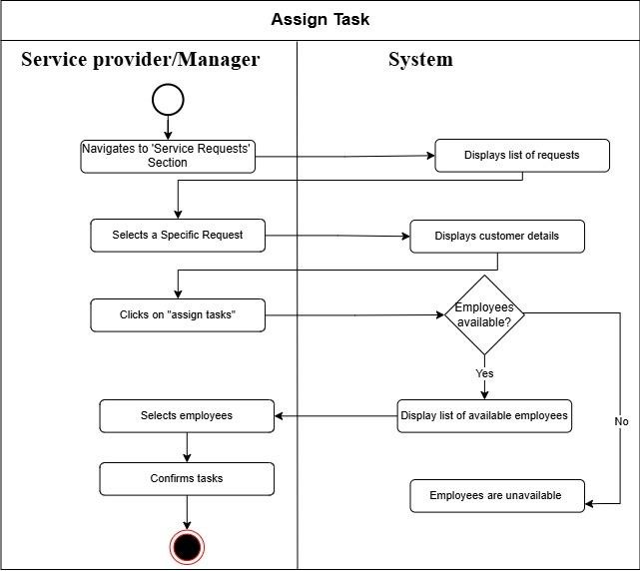
Figure 4.23: Assign Task
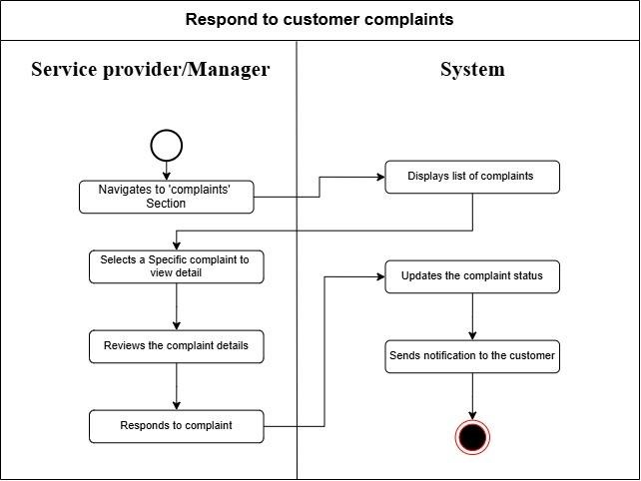
Figure 4.24: Respond to Customer Complaints
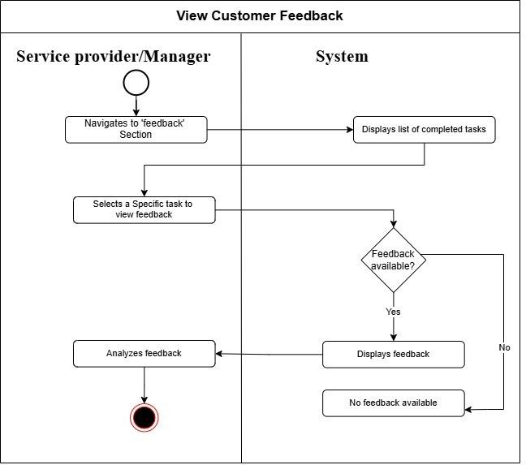
Figure 4.25: View Customer Feedback
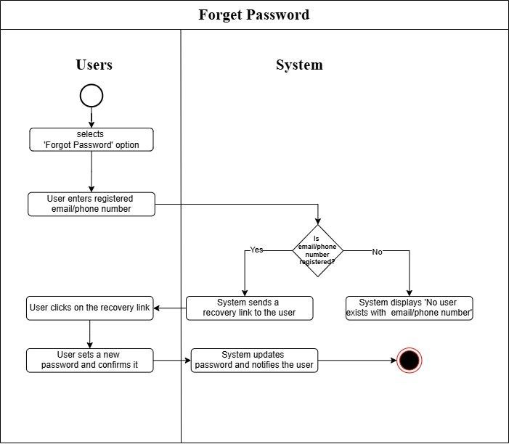
Figure 4.26: Forget Password

4.3.3.3 Employee

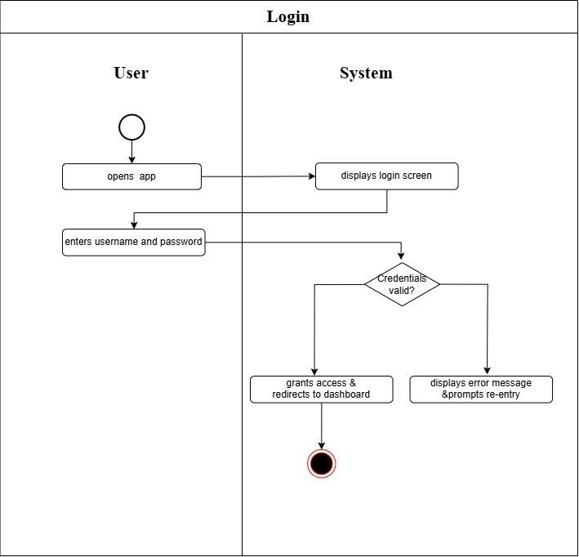
Figure 4.27: Login
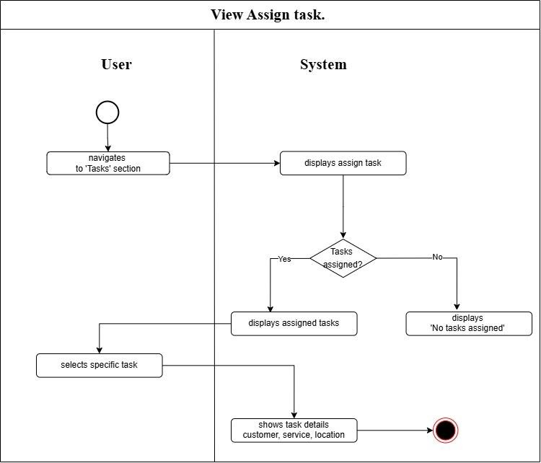
Figure 4.28: View Assign Task
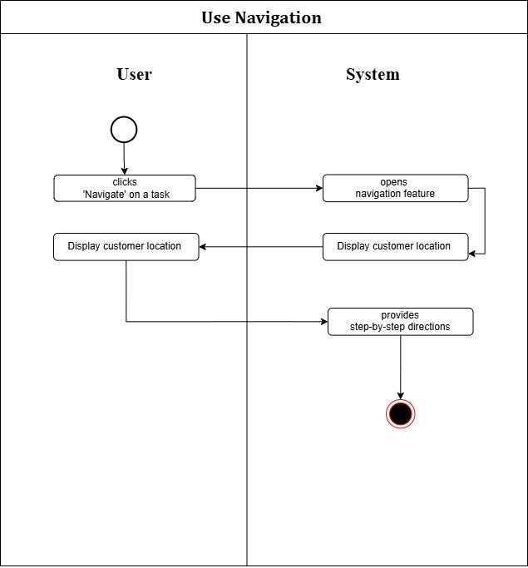
Figure 4.29: Use Navigation

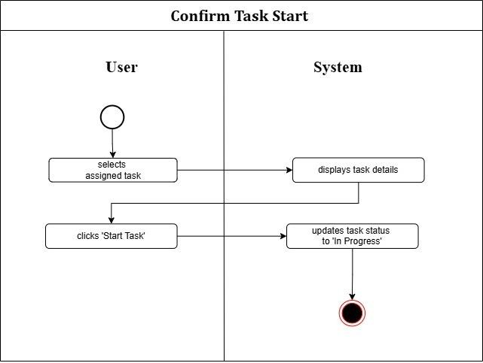
Figure 4.30: Confirm Task Start
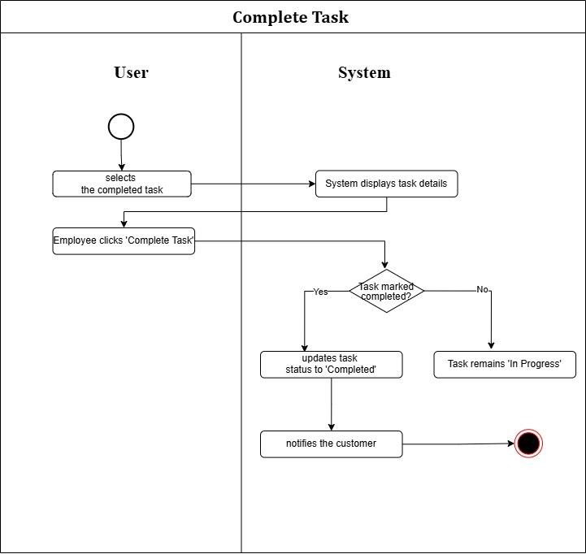
Figure 4.31: Complete Task

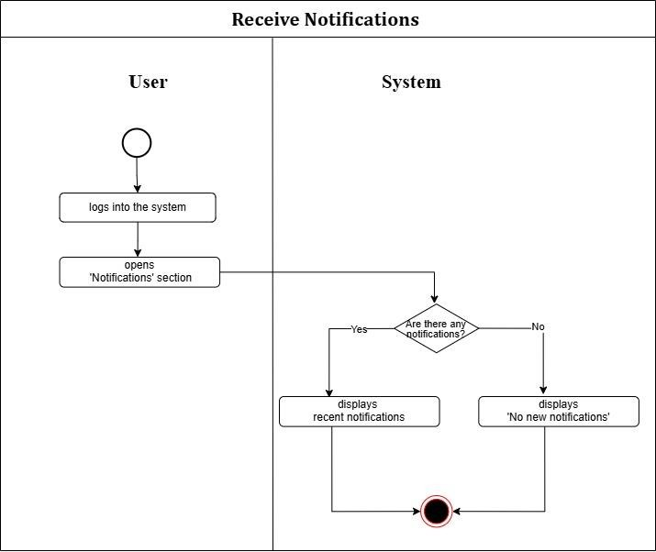
Figure 4.32: Received Notification

4.3.3.4 Admin

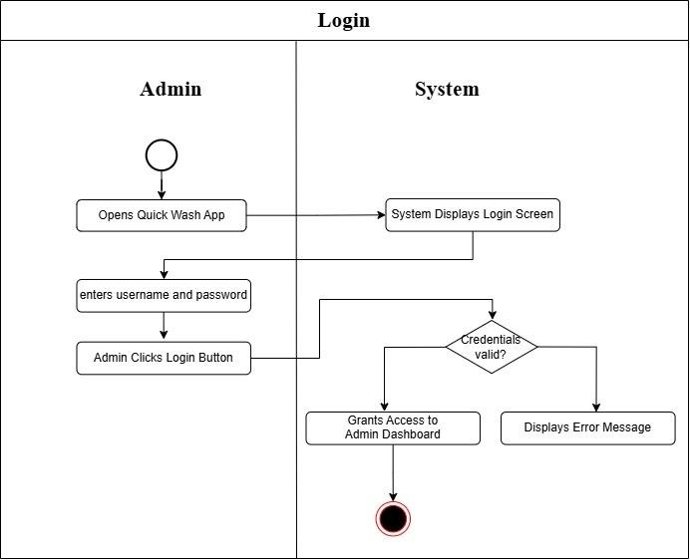
Figure 4.33: Login
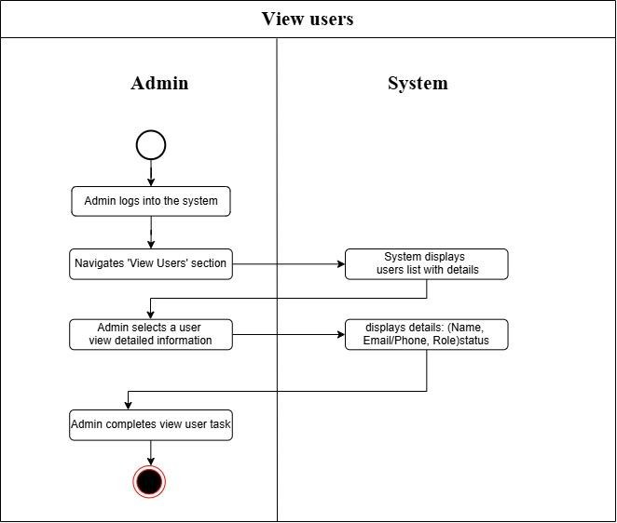
Figure 4.34: View Users

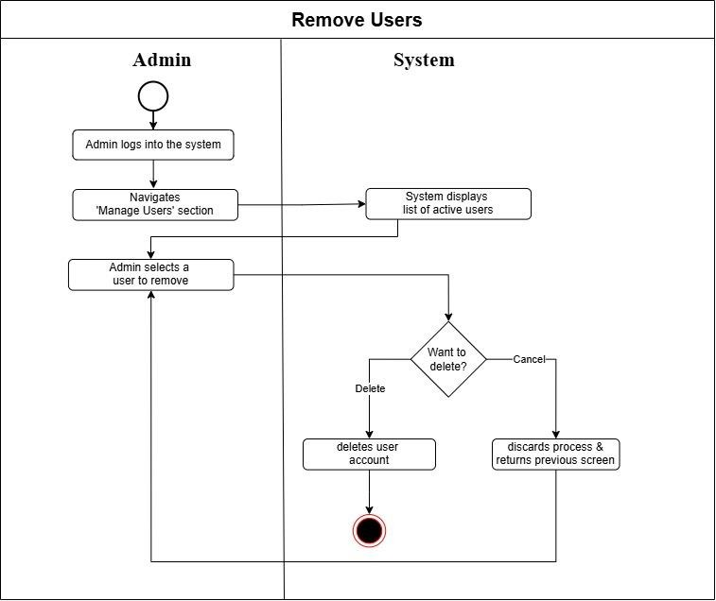
Figure 4.35: Remove Users

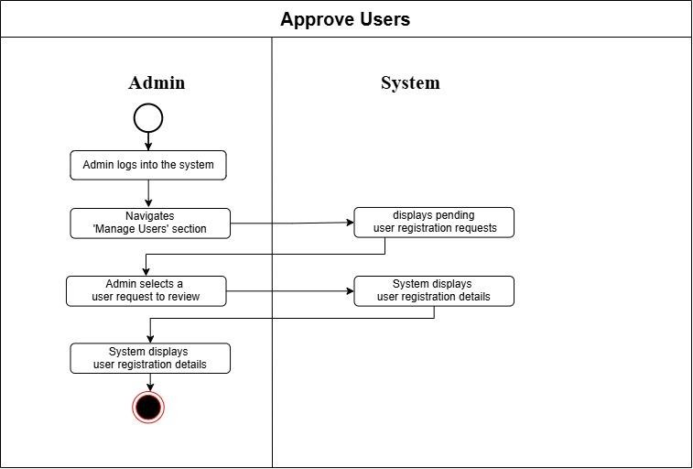
Figure 4.36: Approve Users
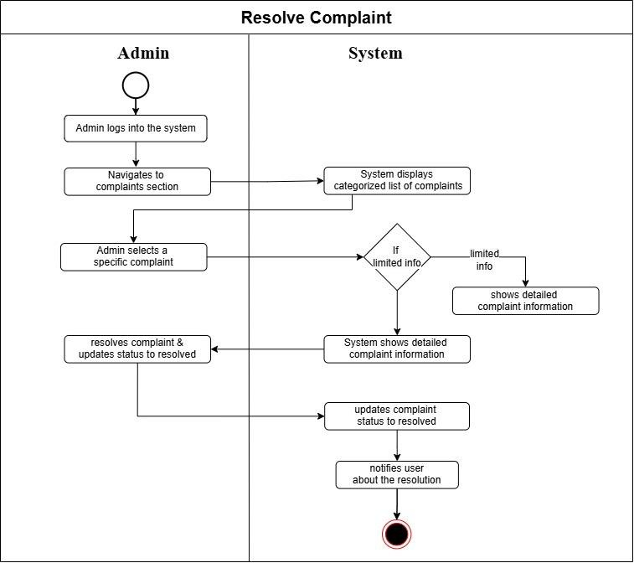
Figure 4.37: Resolved Complaint

4.4 Summary

In this will chapter, we showed the design diagrams like architectural design, use case design, activity design diagrams of our project “Quick Wash”. In all the diagrams we tried to draw out the workflow and technical design of our system “Quick Wash”. This system design helped us in elaborating & understanding the refined aspects of our system.

Chapter 5:
Implementation

Chapter 5:

Implementation

5.1 Endeavour

5.1.1 Team
- Hammad Bin Riaz
- Syed Ahmed Ali Shah

5.1.2 Work Breakdown Structure
1. Project Management
1.1. Work Breakdown Structure (WBS)
1.2. Roles & Responsibility Matrix
1.3. Change Control System
2. Reports / Documentation
2.1. Team Members and Project Proposal
2.2. Project Proposal Document
2.2.1. Opportunities and Stakeholders
2.2.2. Existing Systems
2.2.3. Problem Statement
2.2.4. Proposed Solution
2.2.5. Project Scope
2.2.5.1. Home Service
2.2.5.2. Employee Management System
2.2.5.3. Admin
2.2.5.4. Payment Integration
2.2.5.5. Customer Feedback and Reviews
2.2.5.6. Notification
2.2.6. Technologies
2.3. Proposal Plan
2.3.1. Change Record
2.3.2. List of faculties proposed changes
2.3.3. Work Breakdown Structure

2.4. Process Document
2.4.1. Estimate Documentation
2.5. Planning Document
2.5.1. Problem the Software will solve
2.5.2. The development approach the team will use
2.5.3. The Primary Function of the Software
2.5.4. The Order of Development
2.5.5. Leadership Roles for the Project
2.5.6. Each Team Member’s Responsibilities
2.6. Scheduling Documentation
2.7. Technical Documentation
2.8. Final Documentation Introduction
2.9. Literature / Market Survey
2.9.1. Surveys
2.9.2. Interviews
2.9.3. Brainstorming
2.9.4. Customer observation
2.9.5. Stand-Alone Literature review
2.9.6. Literature review as section within a document
2.10. Requirements Analysis
2.10.1. Elicited Requirements
2.10.2. Business Requirements
2.10.3. Functional Requirements
2.10.4. Stakeholder Requirements
2.11. System Design
2.11.1. Interface Design
2.11.1.1. Graphical User Interface
2.11.1.2. Menu-Driven User Interface
2.11.1.3. Form-Based User Interface
2.11.1.4. Touch User Interface
2.11.2. Architectural Design
2.11.3. Use Cases
2.11.4. Component Diagram
2.11.5. Deployment Diagram
2.11.6. Activity Diagrams
2.12. Implementation
2.13. Testing & Performance Evaluation
2.13.1. System Testing
2.13.2. Load Testing
2.14. Conclusion & Outlook
2.15. End User Documentation
2.15.1. Training Manuals
2.15.2. User Manuals
2.15.3. Release Notes
2.15.4. Installation Guides
2.15.5. Troubleshooting Tips
2.16. Application Administration Documentation
2.17. System Administrator Documentation
2.17.1. Information on Software Installation
2.17.2. Updates
2.17.3. Functionality
3. System
3.1. Development Environment
3.1.1. IDE (VS Code)
3.1.2. Version Control
3.1.3. Server
3.1.4. Database
3.1.4.1. User information
5.1.3 Roles & Responsibility Matrix:

WBS # | WBS  Deliverable | Activity # | Activity to Complete the Deliverable | Duration (Days) | Responsible Team  Members & Roles
2 | Documentation | 2.1 | Team Members  and Project Proposal | 1 | Hammad Riaz, Syed Ahmed Ali
2.2 | Documentation | 2.2 | Project  Proposal Document | 4 | Hammad  Riaz, Syed Ahmed Ali
 | Project Proposal Document | 2.2.1 | Opportunity & Stakeholders | 1 | Hammad Riaz, Syed Ahmed Ali
 |  | 2.2.2 | Existing Systems | 2 | Hammad Riaz, Syed Ahmed Ali
 |  | 2.2.3 | Problem  Statement | 1 | Hammad  Riaz, Syed
 |  | 2.2.4 | Proposed Solution | 1 | Hammad Riaz, Syed  Ahmed Ali
 |  | 2.2.5 | Project Scope | 4 | Hammad Riaz, Syed  Ahmed Ali
 |  | 2.2.5.1 | Home Services | 4 | Hammad  Riaz, Syed Ahmed Ali
 |  | 2.2.5.2 | Base send request | 8 | Hammad Riaz, Syed  Ahmed Ali
 |  | 2.2.5.3
 |  | 2.2.5.4 | Admin | 8 | Hammad Riaz, Syed  Ahmed Ali
 |  | 2.2.5.5 | Types of Services & Types of  Vehicles | 3 | Hammad Riaz, Syed Ahmed Ali
 |  | 2.2.5.6 | Payment Integration | 5 | Hammad Riaz, Syed  Ahmed Ali
 |  | 2.2.5.7 | Customer Feedback &  Reviews | 2 | Hammad Riaz, Syed  Ahmed Ali
2.3 | Proposal Plan | 2.3.1 | Proposed Changes | 2 | Hammad Riaz,
 |  | 2.3.2 | Work  Breakdown Structure | 3 | Hammad  Riaz, Syed Ahmed Ali
2.4 | Planning Document | 2.4.1 | Problem the Software Will  Solve | 1 | Hammad Riaz, Syed  Ahmed Ali
 |  | 2.4.2 | Development Approach | 1 | Hammad Riaz, Syed  Ahmed Ali
 |  | 2.4.3 | Primary Function of  the Software | 1 | Hammad Riaz, Syed  Ahmed Ali
 |  | 2.4.4 | Order of Development | 1 | Hammad  Riaz, Syed Ahmed Ali
 |  | 2.4.5 | Leadership Roles | 1 | Hammad Riaz, Syed
 |  | 2.4.6 | Team Members’ Responsibilities | 1 | Hammad Riaz, Syed Ahmed Ali
2.5 | Documentation | 2.5 | Final Documentation  Introduction | 1 | Hammad Riaz, Syed Ahmed Ali
2.6 | Market Survey | 2.6 | Market Survey | 6 | Hammad Riaz, Syed Ahmed Ali
 |  | 2.6.1 | Surveys | 1 | Hammad Riaz
 |  | 2.6.2 | Interviews | 1 | Hammad Riaz, Syed Ahmed Ali
 |  | 2.6.3 | Brainstorming | 2 | Hammad Riaz, Syed Ahmed Ali
2.7 | Requirement Analysis | 2.7 | Requirement Analysis | 5 | Hammad Riaz, Syed  Ahmed Ali
 |  | 2.7.1 | Elicited Requirement  s | 1 | Hammad Riaz, Syed  Ahmed Ali
 |  | 2.7.2 | Functional  Requirement s | 4 | Hammad  Riaz, Syed Ahmed Ali
 |  | 2.7.4 | Stakeholder Requirement  s | 1 | Hammad Riaz, Syed  Ahmed Ali
2.8 | System Design | 2.8.1 | Interface Design | 8 | Syed Ahmed Ali
 |  | 2.8.2 | Architectural Design | 3 | Hammad Riaz, Syed  Ahmed Ali
 |  | 2.8.3 | Use Cases | 3 | Hammad,  Syed Ahmed
 |  | 2.8.4 | Activity  Diagrams | 5 | Hammad,  Syed Ahmed
2.9 | Implementation | 2.9 | Development | 30 | Hammad,  Ahmed
2.10 | Testing & Performance  Evaluation | 2.10 | Testing & Performance  Evaluation | 8 | Hammad, Syed Ahmed
3 | Development Environment | 3.1 | Development Environment  Setup | 10 | Hammad, Syed Ahmed
3 | Mobile Application | 3.2 | Mobile  Application Development | 40 | Hammad, Syed Ahmed
 |  | 3.2.1 | Front-End | 20 | Hammad Riaz, Syed  Ahmed Ali
 |  | 3.2.2 | Back-End | 20 | Hammad Riaz, Syed  Ahmed Ali

5.2 COMPONENTS, LIBRARIES, WEB SERVICES, AND TECHNOLOGIES
- Node.js
- React Native
- JavaScript
- Express.js
- HTML/CSS
- GitHub
Database
- Mongo DB
Tool for Online Team Collaborations
- Google Meets
- Zoom

5.3 IDE, AND TOOLS

- Visual Studio Code
- Visual Paradigm
- MS Word
- Adobe Illustrator
- Postman
- Trello
- Git
- Expo

5.4 Best Practices/ Coding Standard

5.4.1 Software Engineering Methodologies
We have used the Scrum Agile Methodology for our project since it is more flexible and can adjust to constantly changing project scopes. This is how our project was carried out:
- We take our supervisor as a stakeholder and show our work to him on each sprint of two weeks to take the feedback and then move to next module after the user satisfaction.
- A minimum of fifteen to twenty minutes had been spent on a daily meeting between team members and asked each other questions like:
- What did you do yesterday?
- What will you do today?
- Are there any obstacles or challenges?
- Progress was discussed in meetings with the supervisor, which took place at least once a week.
- During the meeting, a list of work was created (Sprints) and deadlines were planned.
- The group members then completed these tasks and progress was examined on sprint of two weeks.
Product Owner:
Mr. Ahmed Shahzad
Hanzala Iftikhar (Stakeholder)
Scrum Master:
Hammad Bin Riaz
Development Team:
Hammad Bin Riaz
Syed Ahmed Ali Shah
5.4.2 React JS coding standard
- Easy, short, and readable variable and function names.
- Comments as much as needed but not more.
- Use shortcut notation when it makes sense.
- Use the Latest Stable Version
- Backup of the work.

5.5 SUMMARY

In this section, we have outlined the components and libraries integral to our project, aimed at enhancing the user experience. Additionally, we have detailed the Work Breakdown Structure (WBS), tools, IDEs, and adhered to best practices and coding standards within software engineering principles.

Chapter 6:
Testing and Evaluation

Chapter 6

Testing and Evaluation

6.1 Introduction
The Testing and Evaluation phase of software development is essential. It serves as a comprehensive examination of the software to ensure that it is error-free and satisfies each requirement. This stage helps in identifying any errors or issues before the software becoming available to users. By doing different tests, we make sure the software is strong, reliable, and of good quality. It is all about making sure the final product is even better than what people expected. Therefore, in this chapter, we will discuss testing of our application Quick Wash and we will use the White box testing.

6.2 Test Case Design

6.2.1 Edit Profile

Input: Name
Valid:
- {A, B, C, ...}
- {a, b, c, …}

Invalid:
- {!, @, >, $, %, ., (, &, *, ^, ), <, #, ?, /, ;, :, ’, ”, `, ~, =, +, -, _, …}
- {1, 2, 3, 4, …}
- {}

Input: Email
Valid:
- {A, B, C, ...}
- {a, b, c, …}
- {1, 2, 3, 4, …}
- {!, @, >, $, %, (, &, *, ^, ), <, #, ?, /, ;, :, ’, ”, `, ~, =, +, -, _,….}

Invalid:
- {}
Table 6.1: Test Case Design through Use Case
Test  Case ID | Scenario | ECP |  |  |  | Actual Output
Test  Case ID | Scenario | Name | Email | Name | Email
1 | Profile successfully edits | Hammad Riaz | Hammadriaz  9945@gmail  .com | {A, B, C, ...}  {a, b, c, …} | {A, B, C, ...}  {a, b, c, …}  {1, 2, 3, 4, …}  {!, @, >, $, %, (, &, *, ^, ), <, #, ?, /, ;, :, ’, ”, `, ~, =, +, -, _,….} | Profile update  Successfully
2 | Unsuccessfully Profile edits | Hammad Riaz@ | Hammadriaz  9945 | {!, @, >, $, %, ., (, &, *, ^, ), <, #, ?, /, ;, :, ’, ”, `, ~, =, +, -, _, …}  {1, 2, 3, 4, …}  {} | {} | Error  Second  name  should  contain only  alphabets &  Email field don’t empty.

6.2.2 User Login

Input: Email
Valid:
- {A, B, C, ...}
- {a, b, c, …}
- {1, 2, 3, 4, …}
- {!, @, >, $, %, (, &, *, ^, ), <, #, ?, /, ;, :, ’, ”, `, ~, =, +, -, _,….}

Invalid:
- {}
Input: Password
Valid:
- {A, B, C, ...}
- {a, b, c, …}
- {!, @, >, $, %, (, &, *, ^, ), <, #, ?, /, ;, :, ’, ”, `, ~, =, +, -, _,….}
- {1, 2, 3, 4, …}
Invalid:
- {}
Table 6.2: Test Case Design through Use Case
Test  Case ID | Scenario | ECP |  |  |  | Actual Output
Test  Case ID | Scenario | Password | Email | Password | Email
1 | Login Successfully | hammad@1234 | Hammadriaz  9945@gmail  .com | {A, B, C, ...}  {a, b, c, …}  {!, @, >, $, %, (, &, *, ^, ), <, #, ?, /, ;, :, ’, ”, `, ~, =, +, -, _,….}  {1, 2, 3, 4, …} | {A, B, C, ...}  {a, b, c, …}  {1, 2, 3, 4, …}  {!, @, >, $, %, (, &, *, ^, ), <, #, ?, /, ;, :, ’, ”, `, ~, =, +, -, _,….} | Login Successfully
2 | Login failed | hammad@12345678 | Hammadriaz  9945 | {!, @, >, $, %, ., (, &, *, ^, ), <, #, ?, /, ;, :, ’, ”, `, ~, =, +, -, _, …}  {1, 2, 3, 4, …}  {} | {} | Error  Number  should  contain  only 11  digits & Email field don’t empty.

6.2.2 Registration

Input: Email
Valid:
- {A, B, C, ...}
- {a, b, c, …}
- {1, 2, 3, 4, …}
- {!, @, >, $, %, (, &, *, ^, ), <, #, ?, /, ;, :, ’, ”, `, ~, =, +, -, _,….}

Invalid:
- {}
Input: Password
Valid:
- {A, B, C, ...}
- {a, b, c, …}
- {!, @, >, $, %, (, &, *, ^, ), <, #, ?, /, ;, :, ’, ”, `, ~, =, +, -, _,….}
- {1, 2, 3, 4, …}
Invalid:
- {}
Input: Name
Valid:
- {A, B, C, ...}
- {a, b, c, …}
Invalid:
- {}
- {1, 2, 3, 4, …}
- {!, @, >, $, %, (, &, *, ^, ), <, #, ?, /, ;, :, ’, ”, `, ~, =, +, -, _,….}

Test  Case ID | Scenario |  |  | ECP |  |  |  |  | Actual Output
Test  Case ID | Scenario | Password | Email |  |  | Password | Email
1 | Login Successfully | hammad@1234 | Hammadriaz  9945@gmail  .com |  |  | {A, B, C, ...}  {a, b, c, …}  {!, @, >, $, %, (, &, *, ^, ), <, #, ?, /, ;, :, ’, ”, `, ~, =, +, -, _,….}  {1, 2, 3, 4, …} | {A, B, C, ...}  {a, b, c, …}  {1, 2, 3, 4, …}  {!, @, >, $, %, (, &, *, ^, ), <, #, ?, /, ;, :, ’, ”, `, ~, =, +, -, _,….} |  | Login Successfully
2 | Login failed | hammad@12345678 | Hammadriaz  9945 |  |  | {!, @, >, $, %, ., (, &, *, ^, ), <, #, ?, /, ;, :, ’, ”, `, ~, =, +, -, _, …}  {1, 2, 3, 4, …}  {} | {} |  | Error  Number  should  contain  only 11  digits & Email field don’t empty.

